**UNLOCKING 2.0**

**A Project Report Submitted to**

**Jawaharlal Nehru Technological University-Anantapur**

*In partial fulfillment of the requirements*

*for the award of the degree of*

**BACHELOR OF TECHNOLOGY**

in

**COMPUTER SCIENCE AND ENGINEERING**

**By**

**GEETHA KRISHNA P -16AK1A0518**

**BALA KRISHNA B -16AK1A0504**

**PAVAN KUMAR B -16AK1A0550**

**JAYA GANESH K -16AK1A0528**

**Under the guidance of**

**Mr. B. RAMANA REDDY, M. Tech (CS)**

Assistant Professor



**DEPARTMENT OF COMPUTER SCIENCE AND ENGINEERING**

**ANNAMACHARYA INSTITUTE OF TECHNOLOGY AND SCIENCES**

Venkatapuram(V), Karakambadi(Po), Renigunta(M), Tirupati-517520, A.P.

**2016-2020**

**ANNAMACHARYA INSTITUTE OF TECHNOLOGY AND SCIENCES**

Venkatapuram(V), Karakambadi (Po), Renigunta(M), Tirupati-517520, A.P

**DEPARTMENT OF COMPUTER SCIENCE AND ENGINEERING**



**CERTIFICATE**

Certified that this is a Bonafide record of the Project Report entitled, **“UNLOCKING 2.O”**, done by **Mr.GeethaKrishna P, REG NO. 16AK1A0518, Mr.PavanKumar B, REG NO. 16AK1A0550, Mr.Balakrishna B, REG NO. 16AK1A0504, Mr.JayaGanesh K, REG NO. 16AK1A0528,** submitted to the faculty of Computer Science and Engineering, in partial fulfillment of the requirements for the Degree of **BACHELOR OF TECHNOLOGY** in **Computer Science and Engineering** from Jawaharlal Nehru Technological University-A, Anantapur during 2016-2020.

|  |  |
| --- | --- |
| **Guide:**  **Mr. B. Ramana Reddy, MTech (CS)**  **Assistant Professor,**  **Dept of CSE,**  **AITS, Tirupati** | **Head of The Department**  **Mrs. Rupadevi Singh, M.E, (Ph.D.,)**  **Assistant Professor & HOD,**  **Dept of CSE,**  **AITS, Tirupati** |

Date: _______________

Place: Tirupati

**INTERNAL EXAMINER EXTERNAL EXAMINER**

**ANNAMACHARYA INSTITUTE OF TECHNOLOGY AND SCIENCES**

Venkatapuram(V), Karakambadi(Po), Renigunta(M), Tirupati-517520, A.P

**DEPARTMENT OF COMPUTER SCIENCE AND ENGINEERING**



**DECLARATION**

We hereby declare that the project titled ***“*UNLOCKING 2.O”** is a genuine project work carried out by us, in **B. Tech(Computer Science and Engineering)** degree course of **Jawaharlal Nehru Technology University-A, Anantapur** and has not been submitted to any other course or university for the award of our degree by us.

**GEETHA KRISHNA P -16AK1A0518**

**BALA KRISHNA B -16AK1A0504**

**PAVAN KUMAR B -16AK1A0550**

**JAYA GANESH K -16AK1A0528**

**ACKNOWLEDGEMENT**

The satisfaction that accompanies the successful completion of the task would be put incomplete without the mention of the people who made it possible, whose constant guidance and encouragement crown all the efforts with success.

We avail this opportunity to express our deep sense of gratitude and hearty thanks to **Mr. GANGI REDDY,** Hon’ble Secretary of AITS-Tirupati, for providing congenial atmosphere and encouragement.

We show gratitude to **Dr. C. NADHAMUNI REDDY**, **Principal** for having provided all the facilities and support.

We would like to thank **Mrs. RUPADEVI SINGH, Assistant Professor & HOD**, **Computer Science and Engineering** for encouragement at various levels of our Project.

We are thankful to our guide **Mr. B. RAMANA REDDY, Assistant Professor, Computer Science and Engineering** for his sustained inspiring guidance and cooperation throughout the process of this project. His wise counsel and suggestions were invaluable.

We are thankful to **Indian Game Development Challenge (IGDC)** by **APSSDC** for valuable training which helped us a lot.

We express our deep sense of gratitude and thanks to all the **Teaching** and **Non-Teaching Staff** of our college who stood with us during the project and helped us to make it a successful venture.

We place highest regards to our **Parents**, **Friends** and **Well-wishers** who helped a lot in making the report of this project.

**GEETHA KRISHNA P -16AK1A0518**

**BALA KRISHNA B -16AK1A0504**

**PAVAN KUMAR B -16AK1A0550**

**JAYA GANESH K -16AK1A0528**

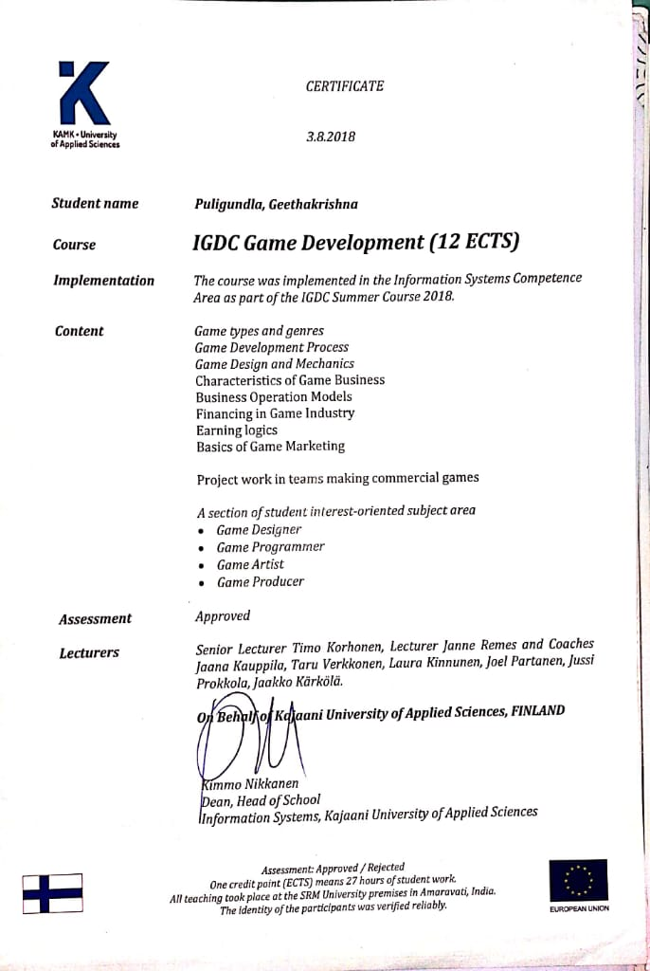

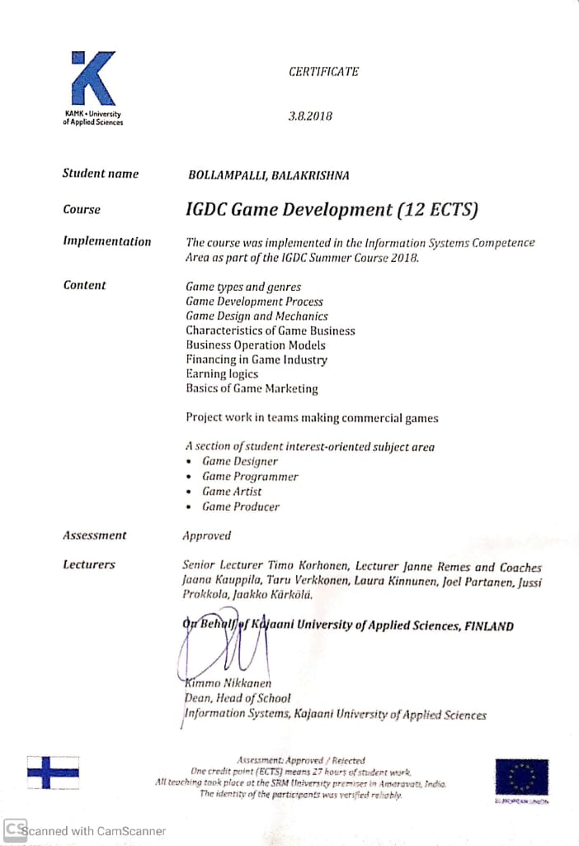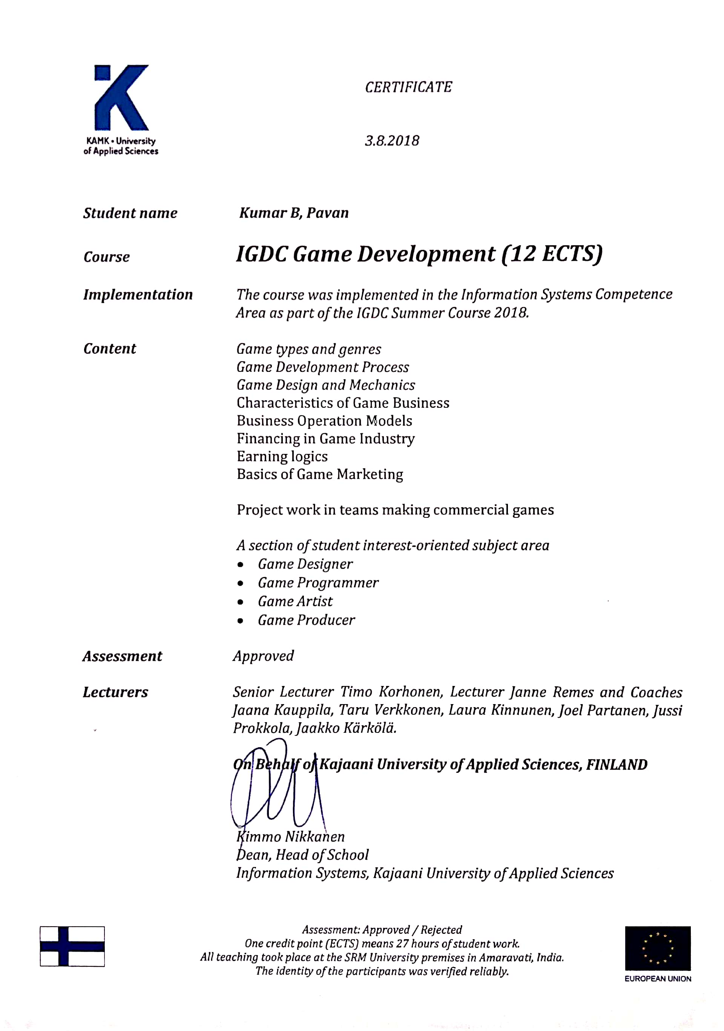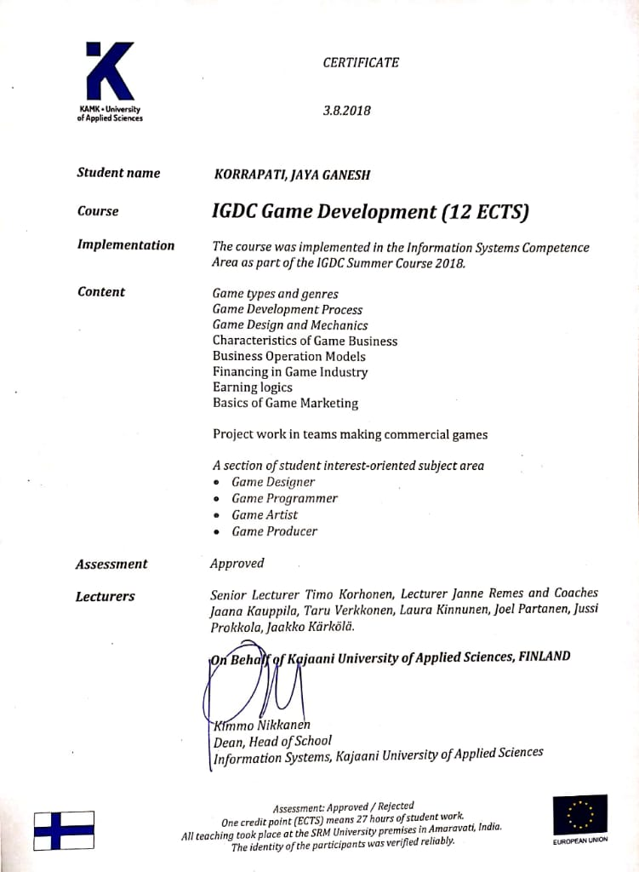

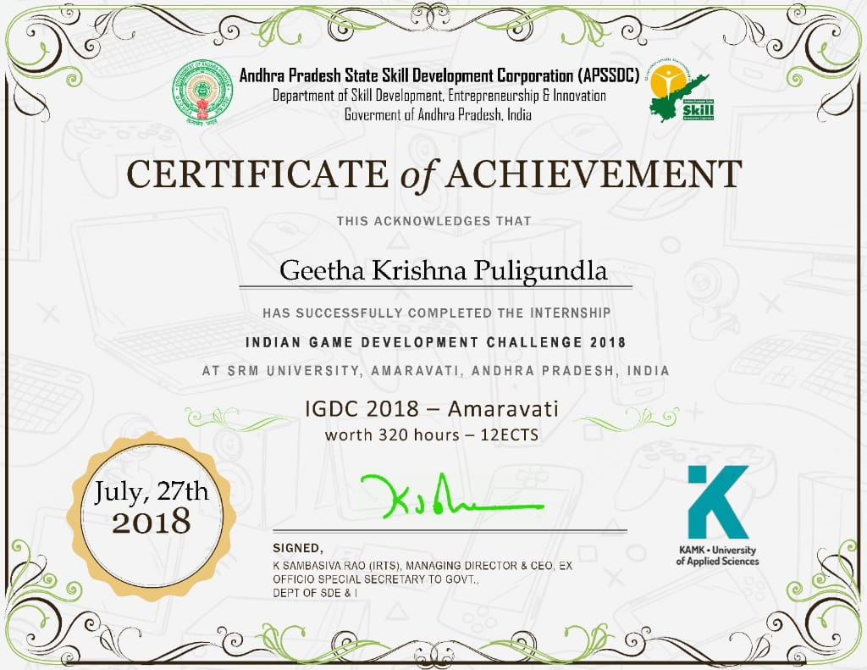

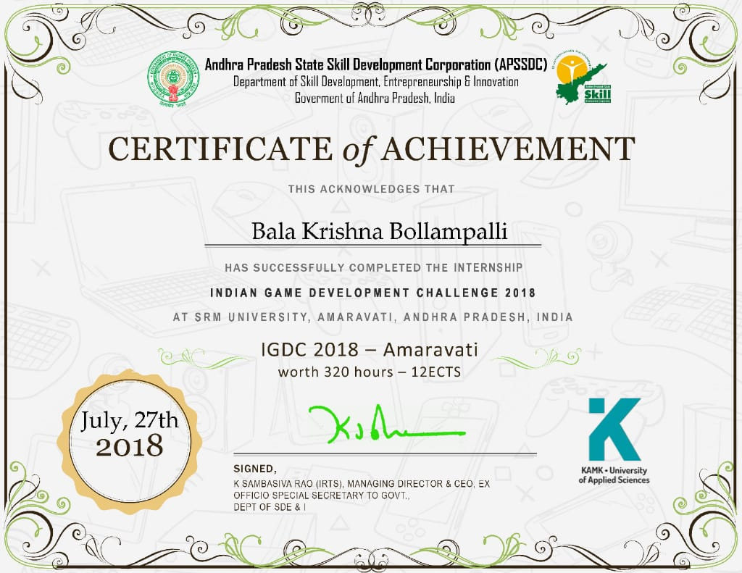

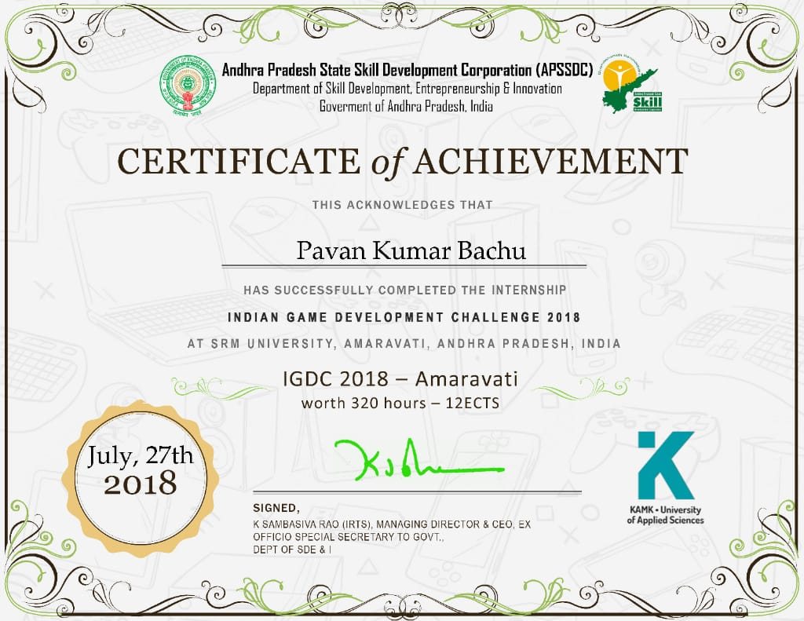

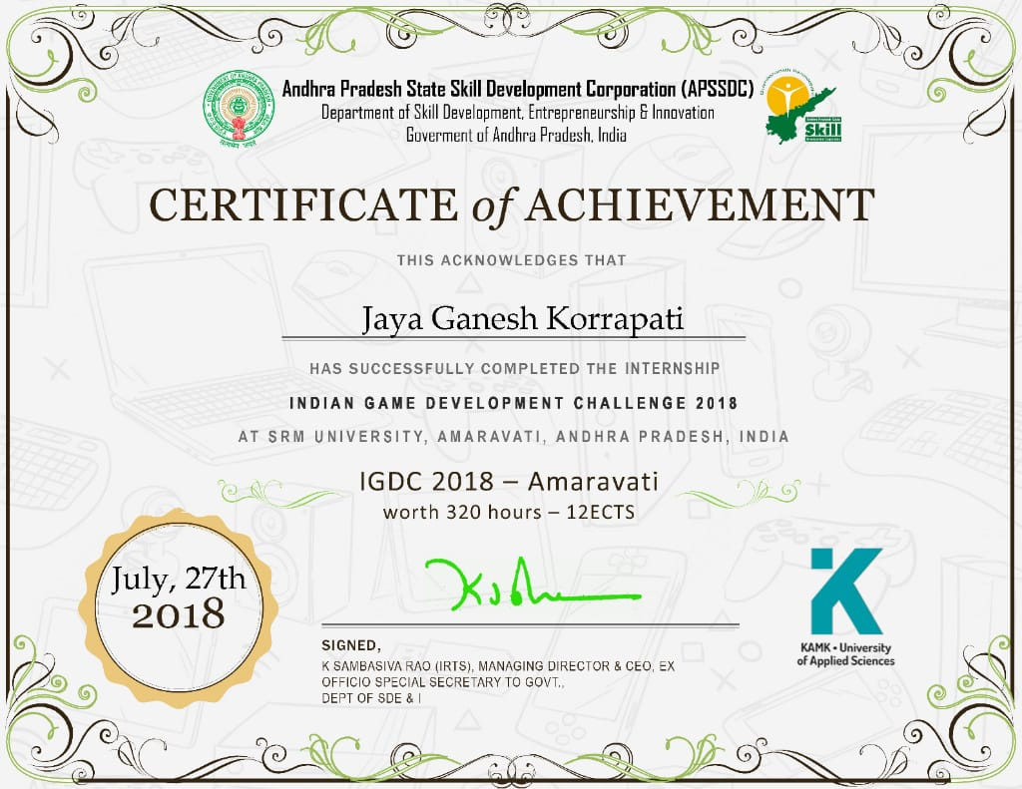

**TABLE OF CONTENTS**

ABSTRACT i

LIST OF FIGURES ii

LIST OF TABLES iv

CHAPTER 1: INTRODUCTION 1

**1.1 Introduction- Gaming in the Field of Software Engineering 1**

**1.2 Basic Overview 1**

**1.2.1 Basic Overview of Game 1**

**1.2.2 Game Details 1**

**1.3 Environment 2**

CHAPTER 2: ANALYSIS 8

**2.1 Introduction 8**

**2.1.1 Technologies, Options and Frameworks used in this game 8**

**2.2 User Requirements 8**

**2.2.1 User Interface Description 8**

**2.2.2 Numbers Generated in Random 9**

**2.2.3 Alphabets Generated in Random 9**

**2.2.4 3x3 Matrix 9**

**2.2.5 4x4 Matrix 10**

**2.3 System Requirements 10**

**2.3.1 Minimum System Requirements 11**

**2.3.2 Recommended System Requirements 11**

CHAPTER 3: DESIGN 13

**3.0 Introduction 13**

**3.1 Data Flow Diagrams 13**

**3.2 UML Diagrams 15**

**3.3 UML Goals 15**

**3.4 Class Diagram 16**

**3.4.1 Benefits of class diagrams 16**

**3.4.2 Basic components of a class diagram 16**

**3.4.3 Member access modifiers 17**

**3.5 Use Case Diagram 18**

**3.5.1 Purpose of Use case Diagrams 18**

**3.6 Sequence Diagram 19**

**3.7 Activity Diagram 20**

**3.7.1 Basic Activity Diagram Notations and Symbols 20**

**3.8 Deployment Diagram 22**

**3.8.1 Deployment diagram applications 22**

**3.8.2 Deployment diagram elements 23**

**3.9 OBJECT DIAGRAM 24**

**3.9.1 Object diagram elements 24**

CHAPTER 4: IMPLEMENTATION AND RESULTS 26

**4.1 Introduction 26**

**4.2 Explanation of key Functions 26**

**4.2.1 Random Number Generator 26**

**4.2.2 Touch Detect 27**

**4.2.3 Background Music script 27**

**4.2.4 Particle Movement 28**

**4.2.5 Countdown 28**

**4.2.6 Chapter Locking 29**

**4.2.7 Chapter_to_Game 29**

**4.2.8 Check Level Completion 30**

**4.2.9 Next Level 30**

**4.2.10 Arcade High Score 30**

**4.2.11 Retry 31**

**4.2.12 Advertisements 31**

**4.9 Output Screens 32**

**4.9.1 Main Menu 32**

**4.9.2 Classic mode 33**

**4.9.3 Chapter Screens 34**

**4.9.4 Normal Chapter 36**

**4.9.5 Memorise Chapter 36**

**4.9.6 Reverse Chapter 37**

**4.9.7 Alfabeto Chapter 38**

**4.9.8 Advanced Chapter 39**

**4.9.9 Result Screens 40**

**4.9.10 Arcade 43**

**4.9.11 Guide 48**

CHAPTER 5: GAME TESTING 51

**5.1 Introduction and Overview 51**

**5.2 Methods used for Game Testing 51**

**5.3 What is Test Case? 53**

**5.4 Testing and Validation 53**

CHAPTER 6: CONCLUSION & FUTURE ENHANCEMENT 62

**6.1 Conclusion 62**

**6.2 Future Enhancement 63**

CHAPTER 7: REFERENCES 64

# 

# ABSTRACT

**Game Logo:**



**Game Design:**

* 2D casual game
* Mobile platform (Android)

**Game Theme:**

Unlocking 2.0 game is all about testing reflexes of the player’s brain. In this game, you’ll be given a random number or set of alphabets on screen and there will be a dotted matrix below just as pattern in your mobile. Players are supposed to connect those dots according to the number given above within the time limit. You can unlock consecutive maps when you reach the minimum required keys. There will be five chapters with different levels in it and each level consists of 3 games that should be completed within given time.

**Software:**

* Krita, Photoshop
* Illustrator

**Tools and engines:**

* Unity Game Engine
* Visual Studio 2017(C#)

# LIST OF FIGURES

|  |  |  |
| --- | --- | --- |
| **S. No** | **Name of the Figure** | **Page No.** |
| Fig 1 | Normal Chapter | 2 |
| Fig 2 | Memorise Chapter | 3 |
| Fig 3 | Reverse Chapter | 4 |
| Fig 4 | Alfabeto chapter | 5 |
| Fig 5 | Advanced Chapter | 6 |
| Fig 6 | Arcade Mode | 7 |
| Fig 7 | 3X3 Matrix | 9 |
| Fig 8 | 4X4 Matrix | 10 |
| Fig 9 | Level 0 DFD | 14 |
| Fig 10 | Level 1 DFD | 14 |
| Fig 11 | Level 2 DFD | 15 |
| Fig 12 | Class Diagram | 17 |
| Fig 13 | Use Case Diagram | 18 |
| Fig 14 | Sequence Diagram | 19 |
| Fig 15 | Activity Diagram | 22 |
| Fig 16 | Deployment Diagram | 23 |
| Fig 17 | Object Diagram | 25 |
| Fig 18 | Main Menu Screen | 33 |
| Fig 19 | Classic Mode Screen | 34 |
| Fig 20 | Chapters Screen | 35 |
| Fig 21 | Normal Chapter Screen | 36 |
| Fig 22 | Memorise chapter Screen | 37 |
| Fig 23 | Reverse Chapter Screen | 38 |
| Fig 24 | Alfabeto chapter Screen | 39 |
| Fig 25 | Advanced Chapter Screen | 40 |
| Fig 26 | Gold Medal Screen | 41 |
| Fig 27 | Silver Medal Screen | 42 |
| Fig 28 | Bronze Medal Screen | 43 |
| Fig 29 | Arcade Mode Screen | 44 |
| Fig 30 | Arcade Easy Screen | 45 |
| Fig 31 | Arcade Medium Screen | 46 |
| Fig 32 | Arcade Hard Screen | 47 |
| Fig 33 | Arcade Result Screen | 48 |
| Fig 34 | Guide Screen | 49 |

|  |  |  |
| --- | --- | --- |
| **S. No** | **Name of the Table** | **Page No.** |
| 1 | Testing reports on the game | 66 |

# LIST OF TABLES

# CHAPTER 1: INTRODUCTION

## 1.1 Introduction- Gaming in the Field of Software Engineering

In the fast-growing field of software engineering and development and even more rapidly growing sector of game development the future is hard to predict. We are working with this game as our software project which is a 3-credit course and as part of our degree we choose this type of work for doing better with development cycle, development period, graphics, scripting, adopting new technology, animation. In general software project is a project focusing on the creation of software. Consequently, Success can be measured by looking at the resulting software. In a game project, the product is a game. But and here comes the point: A game is much more than just its software. It must provide content to become enjoyable. Just like a web server: without content the server is useless, and the quality cannot be measured. This has an important effect on the game project. The software part of the project is not the only one, and it must be considered in connection to all other parts: The environment of the game, the story, characters, game plays, the artwork, and so on.

## 1.2 Basic Overview

### 1.2.1 Basic Overview of Game

Our game is all testing responsiveness and focus. In this game, you’ll be given a random number or alphabets on screen and there will be a dotted matrix below just as pattern in your mobile. Players are supposed to connect those dots according to the number given above within the time limit. You can unlock consecutive maps when you reach the minimum required medals, there will be five chapters with different levels in it and each level consists of 3games that should be completed within given time to get more medals, the faster you match the pattern, the more highest medal you’ll get.

### 1.2.2 Game Details

**Genre**

Unlocking 2.0 is a Simple Puzzle game which sharpens the Brain

**Platform**

Unlocking 2.0 is set to run on mobile platform usually focused on Android Operating system.

**Target demographic**

Our targeted audience is between the ranges of ages 08- 40 years. Anyone who is passionate about Puzzle Games can easily play this game.

**Perspective**

It’s a 2D game.

## 1.3 Environment

There are many types of environments used in our game resembling the different levels.

**Normal Chapter**

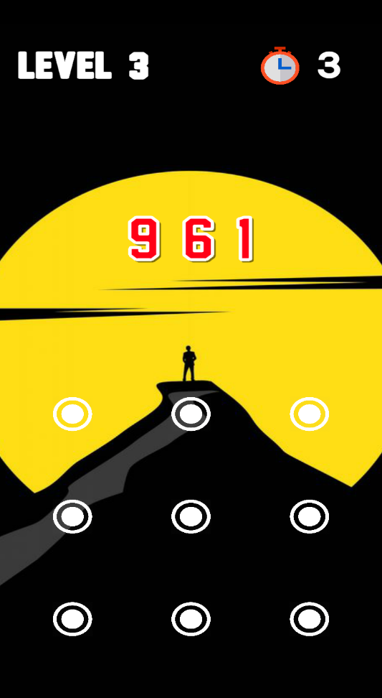In normal chapter the random number is generated and displayed at top of the screen. The size of random number is relied on level. It is very convenient to the players to play. It is simple and easy. If you attempt all the three questions you won a gold medal. Likewise, two for silver and one for bronze medal.

**Fig 1: Normal** **chapter**

**Memorise Chapter:**

In memorise chapter we memorize the random number. The random number is set out over the screen in few seconds, after the number disappears. One should remember the number and drag the dots within a given time limit. This chapter notices how much memory power you have. It enhances the grasping capability of your brain.

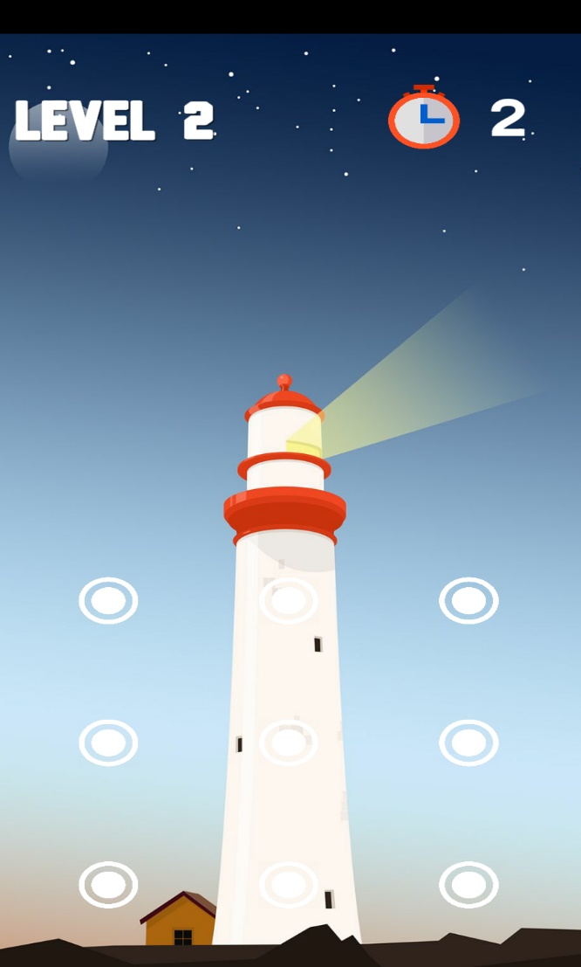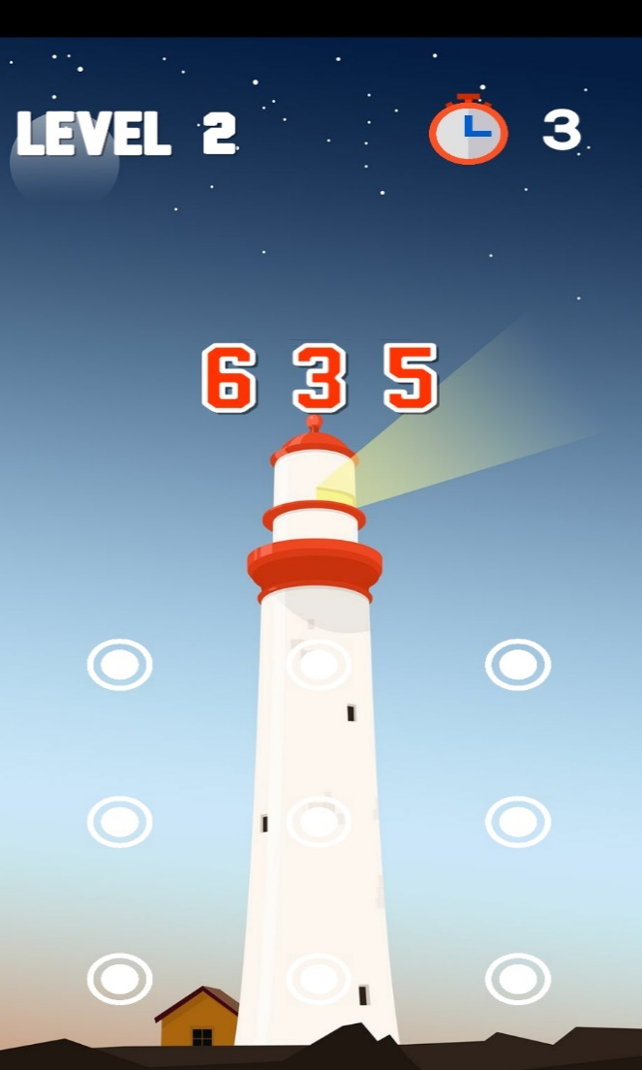

**Fig 2: Memorize chapter**

**Reverse chapter**

In Reverse chapter the random number is generated. The player has to connect the dots in reverse manner within a given time limit. It shows how focused you are while playing game.

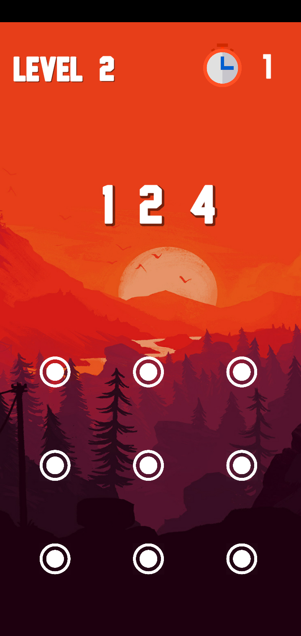

**Fig 3: Reverse chapter**

**Alfabeto chapter**

In Alfabeto chapter the random set of alphabets are generated. The player has to assume dots as alphabets (A to I) and connect the dots within the in a given time limit. It improves Logical ability of brain.

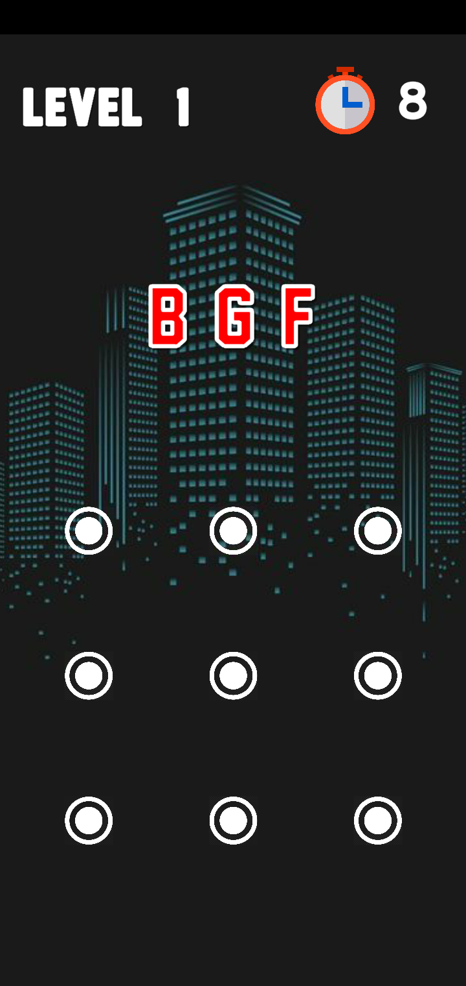

**Fig 4: Alfabeto chapter**

**Advanced chapter**

Advanced chapter will have 16 dots instead of 9. It is the difficult chapter and last one in classic mode. It reflexes complex problem-solving capability.

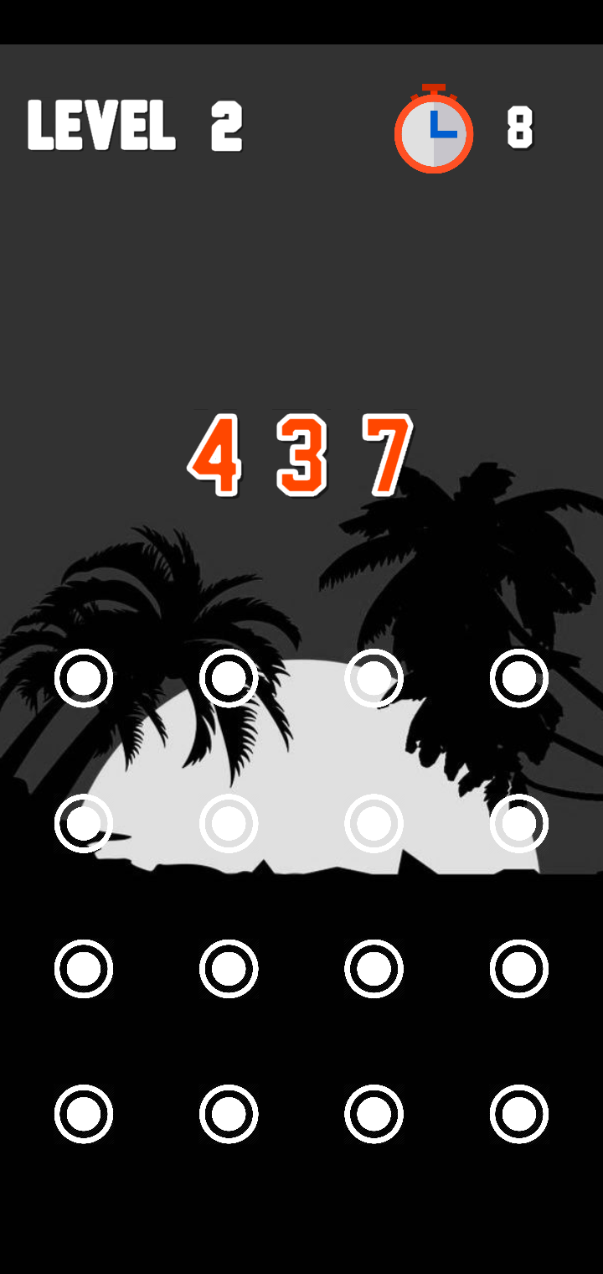

**Fig 5: Advanced chapter**

**Arcade mode**

In this arcade mode there is no limitations to play. It is already in unlock position, directly you move and play in arcade mode it’s your capacity to answer as many questions you can in 60 sec in any difficulty level you want. If you either run out of time or connect wrong dot your score will be displayed. Arcade consists three routines. Here we must attempt n queries within a given time limit. The highest score is credited as high score to the routine.

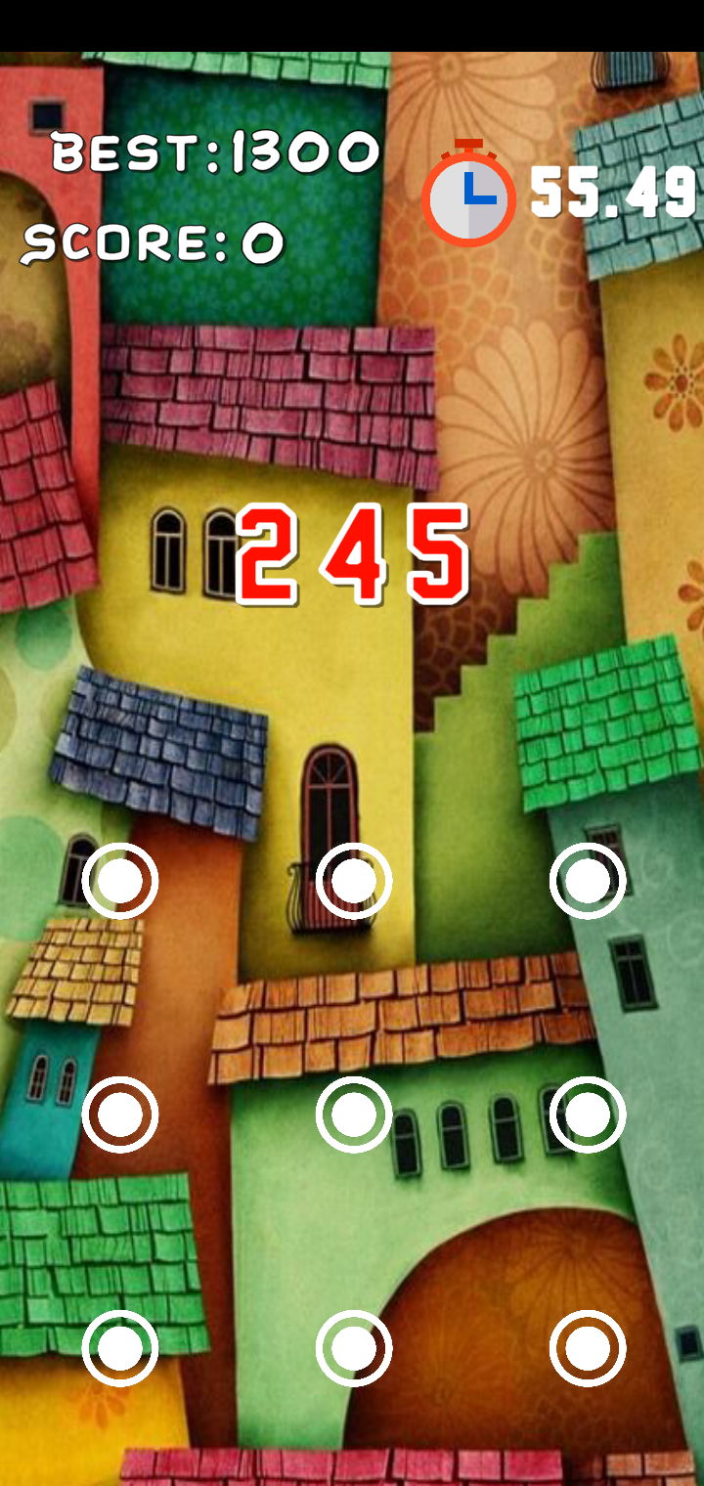

**Fig 6: Arcade Mode**

# CHAPTER 2: ANALYSIS

## 2.1 Introduction

Requirements analysis is the process of determining user expectations for a new or modified product. These features, called requirements, must be quantifiable, relevant and detailed. In software engineering, such requirements are often called functional specifications. Requirements analysis is an important aspect of project management.

Requirements analysis is a team effort that demands a combination of hardware, software and human factors engineering expertise as well as skills in dealing with people.

Requirements analysis involves frequent communication with system users to determine specific feature expectations, resolution of conflict or ambiguity in requirements as demanded by the various users or groups of users, avoidance of feature creep and documentation of all aspects of the project development process from start to finish.

Every application varies in the aspects of options, technologies used and its framework.

### 2.1.1 Technologies, Options and Frameworks used in this game

* Aspect ratio mode : screen (9:16)
* Default Orientation : Portrait
* Use 32-bit display buffer : True
* Color space : Gamma
* Multithreaded Rendering : True
* Game version : 2.0
* Scripting runtime version : Stable (.NET 3.5 Equivalent)
* Android TV compatibility : False
* Company Name : ELITE THUGS

## 2.2 User Requirements

User requirements, often referred to as user needs, describe what the user does with the system, such as what activities that users must be able to perform. In this game the user must have an idea about navigating throughout the game by using UI controls and can be able to understand gameplay by using Guide option. The user must have experienced 2D platform gameplay before starting the game.

### 2.2.1 User Interface Description

As the game is designed for the mobile platform (Android users), the basic user interface is the touch screen. User interacts with the game through the buttons given to them in their touch screen. User will be provided with nine dots which should be joined with the patterns that match the number generated.

### 2.2.2 Numbers Generated in Random

There will be a Number generated at every level in every game which is unique and randomly generated. So, every time user opens the same chapter and same level different number will be generated and displayed which should be matched with pattern to gain the highest medal in the given time limit.

### 2.2.3 Alphabets Generated in Random

There will be a set of alphabets generated in Alfabeto level which is unique and randomly generated. So, every time user opens the same chapter and same level different alphabet will be generated and displayed which should be matched with pattern to gain the highest medal in the given time limit.

### 2.2.4 3x3 Matrix

In Classic mode there will be five chapters, among those first four chapters (Normal, Memorise, Reverse, Alfabeto) will be containing 3x3 matrix i.e., 9 dots with 3 column and 3 rows.

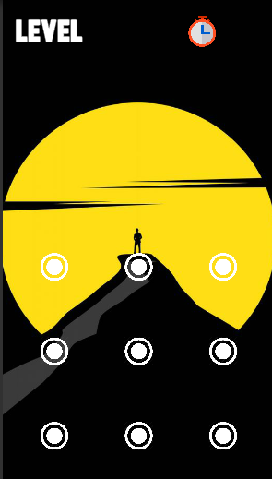

**Fig 7: 3x3 matrix**

### 2.2.5 4x4 Matrix

In Classic mode, Advanced chapter will be containing 4x4 matrix i.e., 16 dots with 4 column and 4 rows.

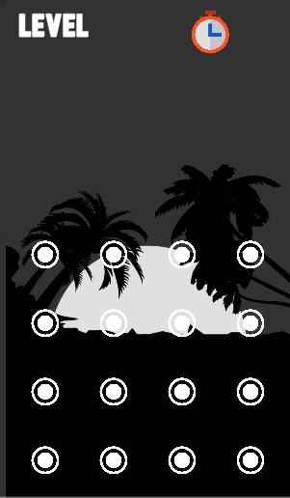

**Fig 8: 4x4 Matrix**

## 

## 2.3 System Requirements

Computer software or any related computer projects needs some hardware components or other supporting compatible software resources to be present on a computer in order to run it properly.  These prerequisites are known as (computer) system requirements and are often used as a guideline as opposed to an absolute rule. Most software defines two sets of system requirements: minimum and recommended. With increasing demand for higher processing power and resources in newer versions of software, system requirements tend to increase over time. Industry analysts suggest that this trend plays a bigger part in driving upgrades to existing computer systems than technological advancements.

A second meaning of the term of System requirements is a generalization of this first definition, giving the requirements to be met in the design of a system or sub-system.  Systems requirements are the building blocks developers use to build the system. These are the traditional “shall” statements that describe what the system “shall do.”

### 2.3.1 Minimum System Requirements

System requirements refer to the hardware and software components of a computer system that are required to install and use software efficiently. System requirements are most commonly seen listed as minimum and recommended requirements.

The minimum system requirements need to be met for the software to run at all on your system, and the recommended system requirements, if met, will offer better software usability.

* **Operating System (API level):** Android 4.1 ‘Jelly Bean’ (API level 16) (64-bit versions only) and above
* **Resolution:** 480*800(min)
* **Processor:** Qualcomm Snapdragon 200 and above
* Number of Cores: 2
* Frequency up to 1.2 GHz
* Instruction Set: ARMv7 32 bits
* **Graphics:** Adreno 302
* Clock: 400 MHz
* Cores: 24ALUs
* **Memory:** 512MB
* **Storage:** 50MB

### 2.3.2 Recommended System Requirements

Often manufacturers of games will provide the consumer with a set of requirements that are different from those that are needed to run software. These requirements are usually called the Recommended Requirements. These requirements are almost always of a significantly higher level than the minimum requirements and represent the ideal situation in which to run the software. This is a better guideline than minimum system requirements in order to have a fully usable and enjoyable experience with software.

These are the few recommended system requirements for this game:

* **Operating System (API level):** Android 5.0 ‘Lollipop’ (API level 21) (64-bit versions only) and above.
* **Resolution:** 1920*1080.
* **Processor**: Qualcomm Snapdragon 600 and above.
* Number of Cores: 4
* Frequency up to 1.7 GHz
* Instruction Set: ARMv7 32 bits
* **Graphics:** Adreno 320
* Clock: 400 MHz
* Cores: 96ALUs
* **Memory:** 1GB
* **Storage:** 100MB

# CHAPTER 3: DESIGN

## 3.0 Introduction

The most creative and challenging phase of the life cycle is system design. The term design describes a final system and the process by which it is developed. It refers to the technical specifications that will be applied in implementations of the candidate system. The design may be defined as “the process of applying various techniques and principles for the purpose of defining a device, a process or a system with sufficient details to permit its physical realization”.

The designer’s goal is how the output is to be produced and in what format. Samples of the output and input are also presented. Second input data and database files have to be designed to meet the requirements of the proposed output. The processing phases are handled through the program Construction and Testing. Finally, details related to justification of the system and an estimate of the impact of the candidate system on the user and the organization are documented and evaluated by management as a step toward implementation.

The importance of software design can be stated in a single word “Quality*”*. Design provides us with representations of software that can be assessed for quality. Design is the only way where we can accurately translate a customer’s requirements into a complete software product or system. Without design we risk building an unstable system that might fail if small changes are made. It may as well be difficult to test or could be one who’s quality can’t be tested. So, it is an essential phase in the development of a software product.

## 3.1 Data Flow Diagrams

Data flow diagrams were popularized in the late 1970s, arising from the book Structured Design, by computing pioneers Ed Yourdon and Larry Constantine. They based it on the “data flow graph” computation models by David Martin and Gerald Estrin. The structured design concept took off in the software engineering field, and the DFD method took off with it. It became more popular in business circles, as it was applied to business analysis, than in academic circle.

Using any convention’s DFD rules or guidelines, the symbols depict the four components of data flow diagrams.

1. **External entity**: an outside system that sends or receives data, communicating with the system being diagrammed. They are the sources and destinations of information entering or leaving the system. They might be an outside organization or person, a computer system or a business system. They are also known as terminators, sources and sinks or actors. They are typically drawn on the edges of the diagram.
2. **Process**: any process that changes the data, producing an output. It might perform computations, or sort data based on logic, or direct the data flow based on business rules. A short label is used to describe the process, such as “Submit payment.”
3. **Data store**: files or repositories that hold information for later use, such as a database table or a membership form. Each data store receives a simple label, such as “Orders.”
4. **Data flow**: the route that data takes between the external entities, processes and data stores. It portrays the interface between the other components and is shown with arrows, typically labeled with a short data name, like “Billing details.

In data flow diagram there are having 3 level’s namely

* Level 0 DFD
* Level 1 DFD
* Level 2 DFD

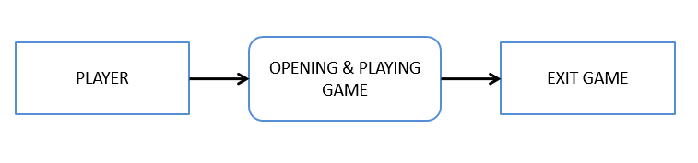

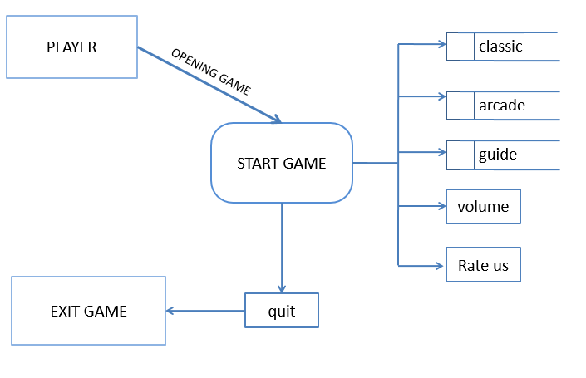**Fig 9 : LEVEL 0 DFD**

**LEVEL 1 DFD**

**Fig 10: LEVEL 1 DFD**

**Fig. 21: LEVEL 1 DFD**

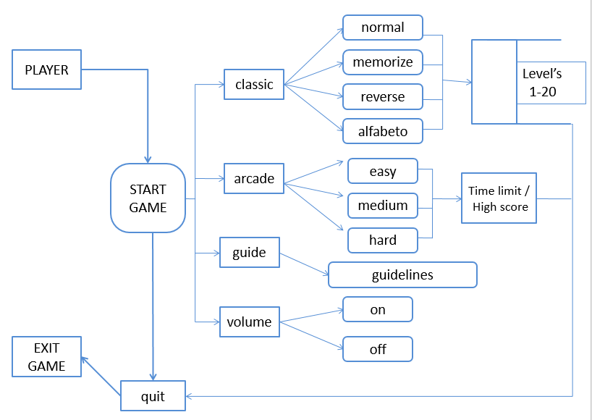

**Fig. 11: LEVEL 2 DFD**

## 3.2 UML Diagrams

UML stands for Unified Modeling Language. UML is a standardized general-purpose modeling language in the field of object-oriented software engineering. The standard is managed, and was created by, the Object Management Group. The goal is for UML to become a common language for creating models of object-oriented computer software. In its current form UML is comprised of two major components: A Meta-model and a notation. In the future, some form of method or process may also be added to; or associated with, UML.

The Unified Modeling Language is a standard language for specifying, Visualization, Constructing and documenting the artifacts of software system, as well as for business modeling and other non-software systems.

The UML represents a collection of best engineering practices that have proven successful in the modeling of large and complex systems. The UML is a very important part of developing objects-oriented software and the software development process. The UML uses mostly graphical notations to express the design of software projects.

## 3.3 UML Goals

The Primary goals in the design of the UML are as follows:

1. Provide users a ready-to-use, expressive visual modeling Language so that they can develop and exchange meaningful models.
2. Provide extendibility and specialization mechanisms to extend the core concepts.
3. Be independent of programming languages and development process.
4. Provide a formal basis for understanding the modeling language.
5. Encourage the growth of OO tools market.
6. Support higher level development concepts such as collaborations, frameworks, patterns and components.
7. Integrate best practices.

## 3.4 Class Diagram

The class diagram is the main building block of object-oriented modeling. It is used for general conceptual modelling of the structure of the application, and for detailed modeling translating the models into programming code. Class diagrams can also be used for data modeling. The classes in a class diagram represent both the main elements, interactions in the application, and the classes to be programmed. In the design of a system, several classes are identified and grouped together in a class diagram that helps to determine the static relations between them. With detailed modelling, the classes of the conceptual design are often split into several subclasses.

### 3.4.1 Benefits of class diagrams

Class diagrams offer several benefits for any organization. Use UML class diagrams to:

1. Illustrate data models for information systems, no matter how simple or complex.
2. Better understand the general overview of the schematics of an application.
3. Visually express any specific needs of a system and disseminate that information throughout the business.
4. Create detailed charts that highlight any specific code needed to be programmed and implemented to the described structure.
5. Provide an implementation-independent description of types used in a system that are later passed between its components.

### 3.4.2 Basic components of a class diagram

The standard class diagram is composed of three sections:

1. Upper section: Contains the name of the class. This section is always required, whether you are talking about the classifier or an object.
2. Middle section: Contains the attributes of the class. Use this section to describe the qualities of the class. This is only required when describing a specific instance of a class.
3. Bottom section: Includes class operations (methods). Displayed in list format, each operation takes up its own line. The operations describe how a class interacts with data.

### 3.4.3 Member access modifiers

All classes have different access levels depending on the access modifier (visibility). Here are the access levels with their corresponding symbols:

* Public (+)
* Private (-)
* Protected (#)
* Package (~)
* Derived (/)
* 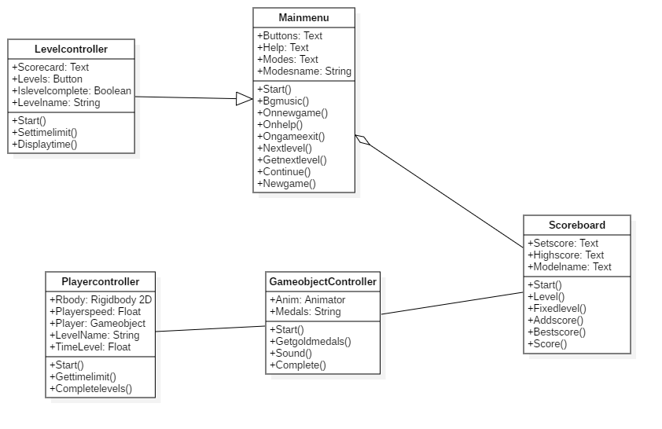Static(underlined)

**Fig 12: Class diagram of UnlocKing 2.0**

In above Class Diagram shows 5 classes Namely Main menu, Scoreboard, Classic mode, Arcade mode player rules. The Relationship between Main menu and Scoreboard is aggregation relationship. Player rules class is fully dependent on Scoreboard class, So the relationship is aggregation.

## 3.5 Use Case Diagram

A use case diagram in the Unified Modeling Language (UML) is a type of behavioral diagram defined by and created from a Use-case analysis. Its purpose is to present a graphical overview of the functionality provided by a system in terms of actors, their goals (represented as use cases), and any dependencies between those use cases. The main purpose of a use case diagram is to show what system functions are performed for which actor. Roles of the actors in the system can be depicted.

### 3.5.1 Purpose of Use case Diagrams

Use case diagrams are used to gather the requirements of a system including internal and external influences. These requirements are mostly design requirements. Hence, when a system is analyzed to gather its functionalities, use cases are prepared and actors are identified. When the initial task is complete, use case diagrams are modelled to present the outside view.

In brief, the purposes of use case diagrams can be said to be as follows −

1. Used to gather the requirements of a system.
2. Used to get an outside view of a system.
3. Identify the external and internal factors influencing the system.
4. 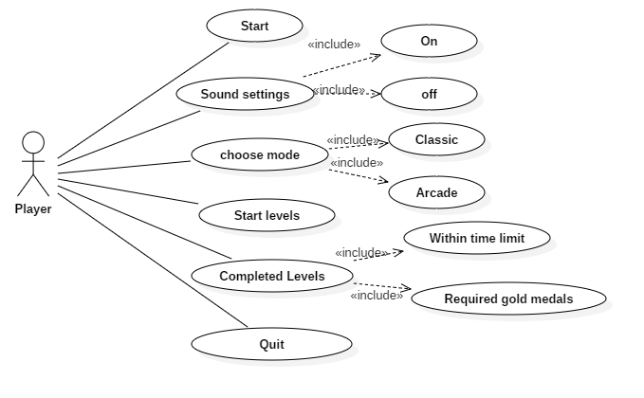Show the interaction among the requirements are actor

**Fig 13: Use case diagram of UnlocKing 2.0**

In the above Use Case Diagram, the actor is a player of the game. There are many use cases used in this game. Whenever the game is started, actor gets five use cases, either to open new game or go to options or choosing mode or choosing to help or exiting the game. When a user chooses to play new game, the new game will start.

## 3.6 Sequence Diagram

A sequence diagram in Unified Modeling Language (UML) is a kind of interaction diagram that shows how processes operate with one another and in what order. It is a construct of a Message Sequence Chart. Sequence diagrams are sometimes called event diagrams, event scenarios, and timing diagrams.

A sequence diagram shows, as parallel vertical lines (*lifelines*), different processes or objects that live simultaneously, and, as horizontal arrows, the messages exchanged between them, in the order in which they occur. This allows the specification of simple runtime scenarios in a graphical manner.

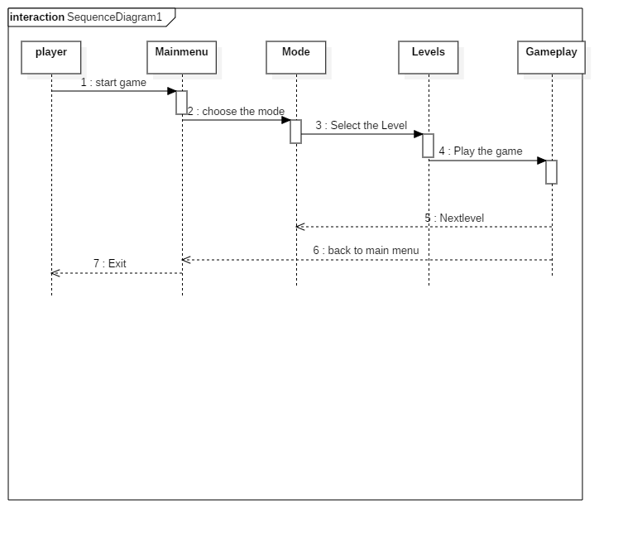

**Fig 14: Sequence diagram of UnlocKing 2.0**

In the above sequence diagram, a player is an actor. Main menu, Gameplay are the objects included in the sequence diagram as shown in the above diagram. An actor goes to the Main menu objects and then gameplay starts by interacting with Gameplay. If Player choose the mode to play and goes to levels keeps on moving until completes the chosen level (currently playing level). If level does not complete with gold medals again replay the game until the player gets Gold medals occurs, then an actor can restart the game or go to main menu or exit from the game.

## 3.7 Activity Diagram

Activity diagram is another important diagram in UML to describe the dynamic aspects of the system. Activity diagram is basically a flowchart to represent the flow from one activity to another activity. The activity can be described as an operation of the system. The control flow is drawn from one operation to another. This flow can be sequential, branched, or concurrent. Activity diagrams deal with all type of flow control by using different elements such as fork, join, etc.,

Activity is an operation of the system. Activity diagrams are not only used for visualizing the dynamic nature of a system, but they are also used to construct the executable system by using forward and reverse engineering techniques.

### 3.7.1 Basic Activity Diagram Notations and Symbols

**Initial State or Start Point**

A small filled circle followed by an arrow represents the initial action state or the start point for any activity diagram. For activity diagram using swim lanes, make sure the start point is placed in the top left corner of the first column.

**Activity or Action State**

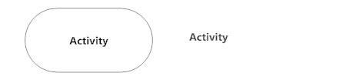An action state represents the non-interruptible action of objects. You can draw an action state in Smart Draw using a rectangle with rounded corners.

**Action Flow**

Action flows, also called edges and paths, illustrate the transitions from one action state to another. They are usually drawn with an arrowed line.

**Object Flow**

Object flow refers to the creation and modification of objects by activities. An object flow arrow from an action to an object means that the action creates or influences the object. An object flow arrow from an object to an action indicates that the action state uses the object.

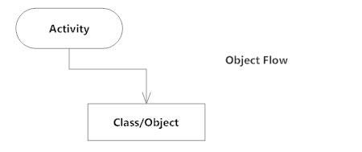

**Decisions and Branchi**n**g**

A diamond represents a decision with alternate paths. When an activity requires a decision prior to moving on to the next activity, add a diamond between the two activities. The outgoing alternates should be labeled with a condition or guard expression. You can also label one of the paths "else."

**Guards**

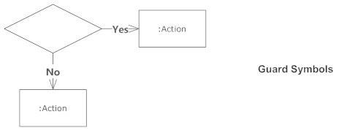In UML, guards are a statement written next to a decision diamond that must be true before moving next to the next activity. These are not essential, but are useful when a specific answer, such as "Yes, three labels are printed," is needed before moving forward.

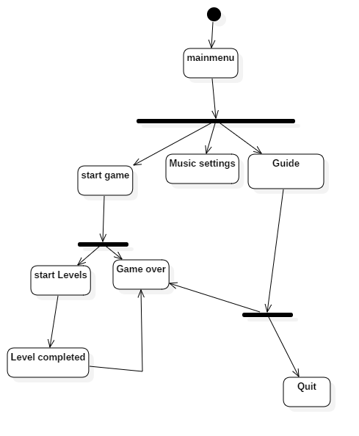

**Fig 15: Activity diagram of UnlocKing 2.0**

In the above Activity diagram, the elements which we used are Activity, Control Flow, Initial Node, Final Node, and Decision Nodes. The Control flow starts from Initial node to Main menu, which is another activity, then based on player decisions the control flow continues to various activities by using Decision node, so that player can choose either New game or in game Options or help panel or player can exit i.e., control flow to final node. Then player can choose different options based on the Activities, so in this game we have four menus which are Main menu, Game over menu and Quit menu. The Control flow is dependent on the player interaction throughout the game.

## 3.8 Deployment Diagram

Deployment diagrams are made up of several UML shapes. The three-dimensional boxes, known as nodes, represent the basic software or hardware elements, or nodes, in the system. Lines from node to node indicate relationships, and the smaller shapes contained within the boxes represent the software artifacts that are deployed.

### 3.8.1 Deployment diagram applications

Deployment diagrams have several valuable applications. You can use them to:

* Show which software elements are deployed by which hardware elements.
* Illustrate the runtime processing for hardware.
* Provide a view of the hardware system’s topology.

### 3.8.2 Deployment diagram elements

A variety of shapes make up deployment diagrams. This list offers an overview of the basic elements you may encounter, and you can see most of these items illustrated in the image below.

**Artifact**: A product developed by the software, symbolized by a rectangle with the name and the word “artifact” enclosed by double arrows.

**Association**: A line that indicates a message or other type of communication between nodes.

**Component**: A rectangle with two tabs that indicates a software element.

**Dependency**: A dashed line that ends in an arrow, which indicates that one node or component is dependent on another.

**Interface**: A circle that indicates a contractual relationship. Those objects that realize the interface must complete some sort of obligation.

**Node**: A hardware or software object, shown by a three-dimensional box.

Node as container: A node that contains another node inside of it such as where the nodes contain components.

**Stereotype**: A device contained within the node, presented at the top of the node, with the name bracketed by double arrows.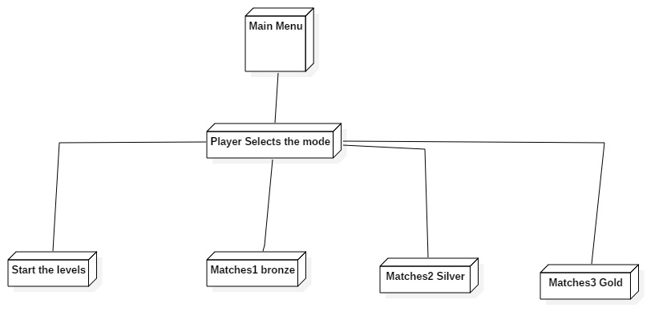

**Fig 16 : Deployment diagram of UnlocKing 2.0**

In the above Deployment Diagram shows that association relationship that indicates a message or other type of communication between nodes.

## 3.9 OBJECT DIAGRAM

An object diagram focuses on the attributes of a set of objects and how those objects relate to each other. For instance, in this object diagram below, all three bank accounts tie back to the bank itself. The class titles show the type of accounts (savings, checking, and credit card) that a given customer could have with this particular bank. The class attributes are different for each account type. For example, the credit card object has a credit limit, while the savings and checking accounts have interest rates. To take a closer look at this document.

Object diagrams are not limited to banking use cases, however, as you can easily make an object diagram for family trees, corporate departments, or any other system with interrelated parts.

### 3.9.1 Object diagram elements

Object diagrams are simple to create: they're made from objects, represented by rectangles, linked together with lines. Take a look at the major elements of an object diagram.

#### *Objects*

Objects are instances of a class. For example, if "car" is a class, a 2007 Nissan Altima is an object of a class.

#### Class titles

Class titles are the specific attributes of a given class. In the [family tree object diagram](https://www.lucidchart.com/documents/editNewOrRegister/2d7c02cb-9ec6-4ad5-96b6-96baa5f8f04e/), class titles include the name, gender, and age of the family members. You can list class titles as items on the object or even in the properties of the object itself (such as color).

#### Class attributes

Class attributes are represented by a rectangle with two tabs that indicates a software element.

#### Links

Links are the lines that connect two shapes of an object diagram to each other. The corporate object diagram below shows how departments are connected in the traditional organizational chart style.

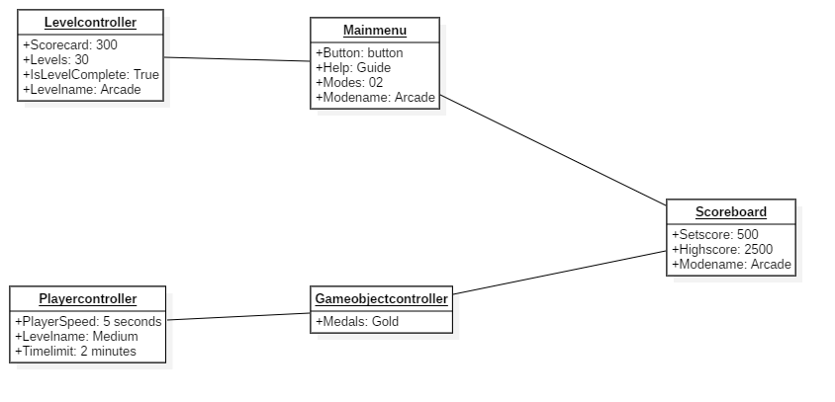

**Fig 17: Object diagram of UnlocKing 2.0**

# CHAPTER 4: IMPLEMENTATION AND RESULTS

## 4.1 Introduction

A product software implementation method is a blueprint to get users and/or organizations running with a specific software product. The method is a set of rules and views to cope with the most common issues that occur when implementing a software product: business alignment from the organizational view and acceptance from human view. The implementation of product software, as the final link in the deployment chain of software production, is in a financial perspective of a major issue. Software implementation may refer to a specific piece of software together with its software features and software quality aspects, a specific programming language implementation the process of [computer programming](https://en.wikipedia.org/wiki/Computer_programming) the broader process of software construction integrating software into the workflow of an organization using a product software implementation method.

## 4.2 Explanation of key Functions

A function is a unit of code that is often defined by its role within a greater code structure. Specifically, a function contains a unit of code that works on various inputs, many of which are variables, and produces concrete results involving changes to variable values or actual operations based on the inputs. Number of functions works together to develop working software. Numbers of functions are used in this project. Some of the major functions used in this project are:

### 4.2.1 Random Number Generator

In these game by using random function we can generate random numbers in each game. There are many levels in this game all the levels player gets different types of numbers those patterns will be generated by using function called random function. It checks all the possibility functions to generate a different pattern for different games.

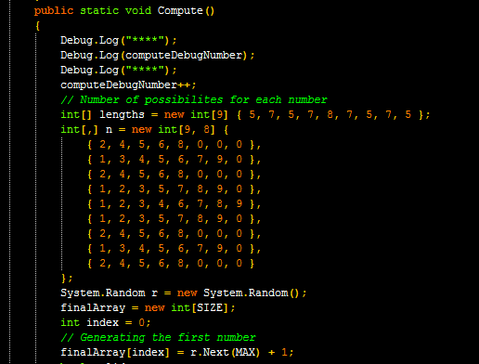

### 4.2.2 Touch Detect

In order to find which dots are clicked we use this function

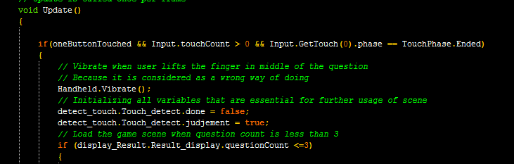

### 4.2.3 Background Music script

By using background sound script, we were added background music for this game. By listening this sound, the player can play the game. The background music will start automatically when player starts game.

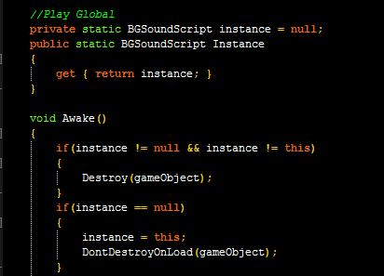

### 4.2.4 Particle Movement

It is used to show some effect while drawing over the dots (Trail rendering)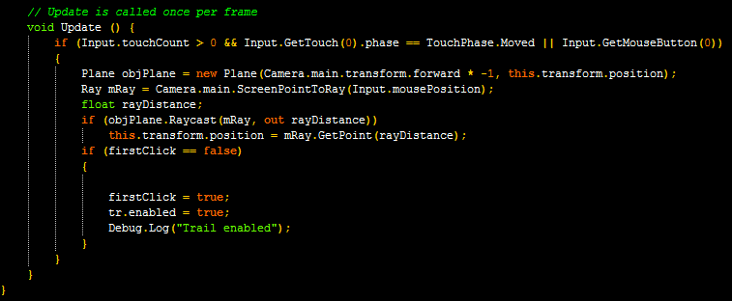

### 4.2.5 Countdown

When player starts the game, the timer can be alerted and if the player touches the wrong digit the time will be pause at that particular time and again it will automatically continue the remaining time.

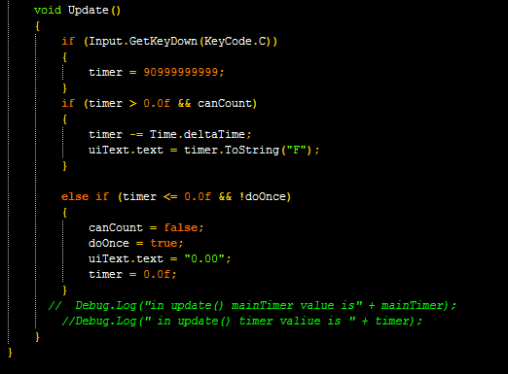

### 4.2.6 Chapter Locking

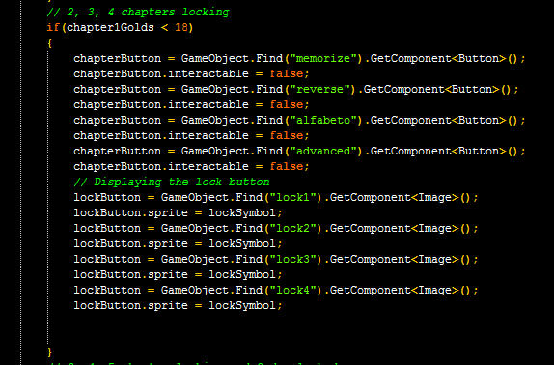 Here we Lock the chapters and based on number of gold medals we got, it results in unlocking next chapters

### 4.2.7 Chapter_to_Game

We are entering into Game scene from levels Scene

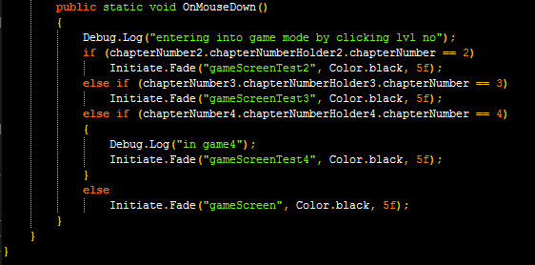

### 4.2.8 Check Level Completion

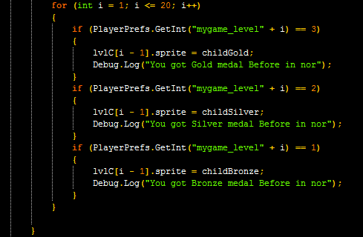Each level has 3 questions and after completion in order to display medal we check number of questions are correct

### 4.2.9 Next Level

### 4.2.10 Arcade High Score

Based on the number of questions drawn correctly we display the high score by

multiplying with 100

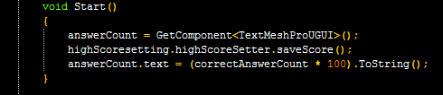

### 4.2.11 Retry

If User want to retry the game for higher medal then it goes back to Game Screen

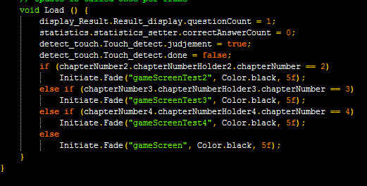

### 4.2.12 Advertisements

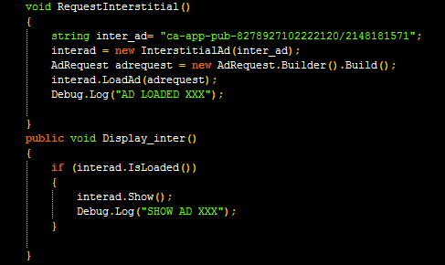By using show interstitial Ads, we were added advertisements in our game.

## 4.9 Output Screens

An output screen is a device used to display output. An output screen could be a separate monitor, or another display device used only to display the output being received from the computer or other devices.

An example of output is anything you view on your computer monitor screen such as the words you type on your keyboard.

The Output screen is the fourth wizard screen of the Map Features dialog, and lets you specify where to store the output of the feature mapping.

Once the data is in the program you want the system to output responses, these may take the form of output to a screen: graphics, text, output to a sound device, etc.

The following given screen is the main home screen of the game. This is the main screen of the game.

It’s a first screen displayed to the player once the game is successfully loaded in his mobile device. This is also known as the main menu screen of the game. Various menus that a player can usually switch are displayed to the player in this screen. Player can choose his preferred. Whenever a player wants to exit an initial mission, he will be diverted back to this same screen.

Different options given to the player are New Game, Options, Help, and Exit. Player can either play game of his preferred level, or manipulate the sound system, enquiry the help and incase, he wants to quit the game, player can choose the exit option.

### 4.9.1 Main Menu

This is the main page of this game the game “UnlocKing 2.0” has two modes one is Classic mode and another one is Arcade mode. And here we placed a guide if a player gets any doubt about the game player can check the guide for an information. In this page the music button provided if the player wants music then player can on the music otherwise can off and at the right corner of the page has main power button if player needs to off the game, they can press that button then automatically the game page will close.

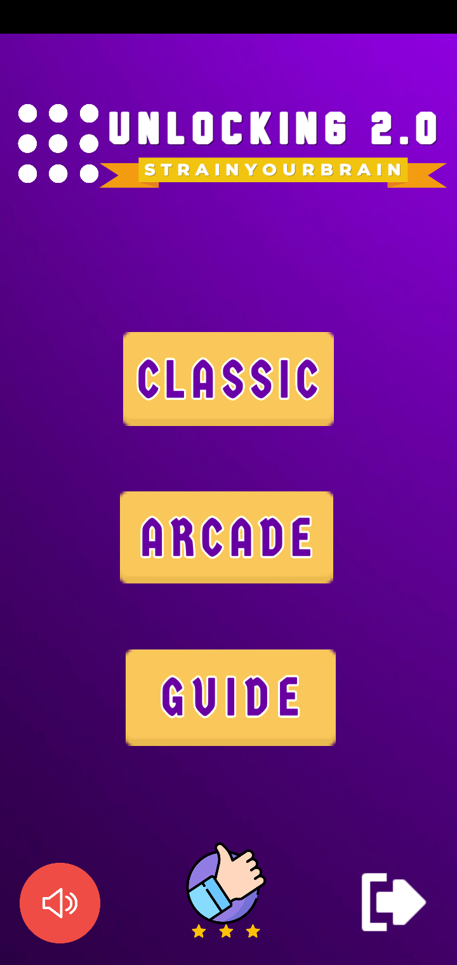

**Fig 18: Main menu screen**

### 4.9.2 Classic mode

These are five chapters in a classic mode. If the player wants to unlock the next chapter player needs minimum required medals. To unlock Memorise chapter player needs to collect eighteen Gold medals from normal mode then same for other chapters. player wants to collect then only player can open another chapter. The Normal mode, Memorise mode, Reverse mode, Alfabeto mode all are in a 3x3 matrix and the Advanced mode is in a 4x4 matrix.

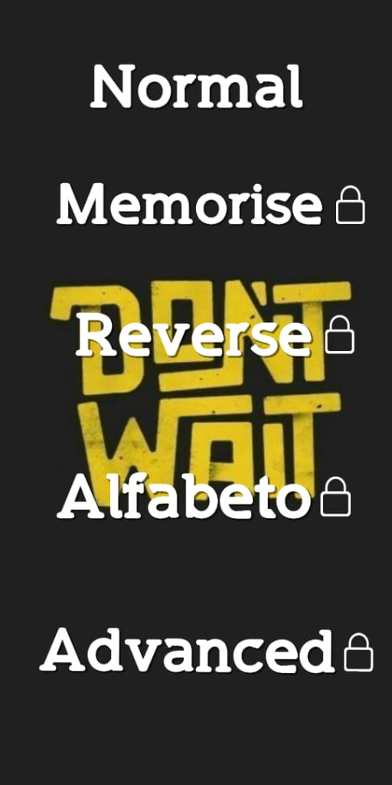

**Fig 19: Classic mode screen**

### 4.9.3 Chapter Screens

In Classic Mode we have 5 different chapters and each chapter have 20 levels

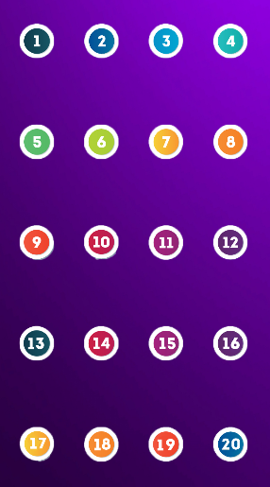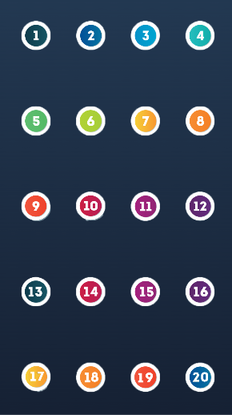

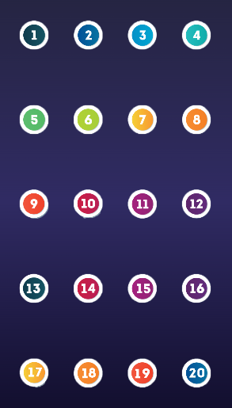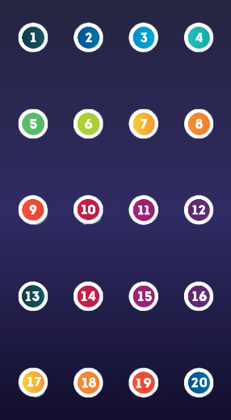

**Fig 20: Chapter Screens**

### 4.9.4 Normal Chapter

In normal chapter the random number is generated and displayed at top of the screen. The size of random number is relied on level. It is very convenient to the players to play. It is simple and easy. If you attempt all the three questions you won a gold medal. Likewise, two for silver and one for bronze medal.

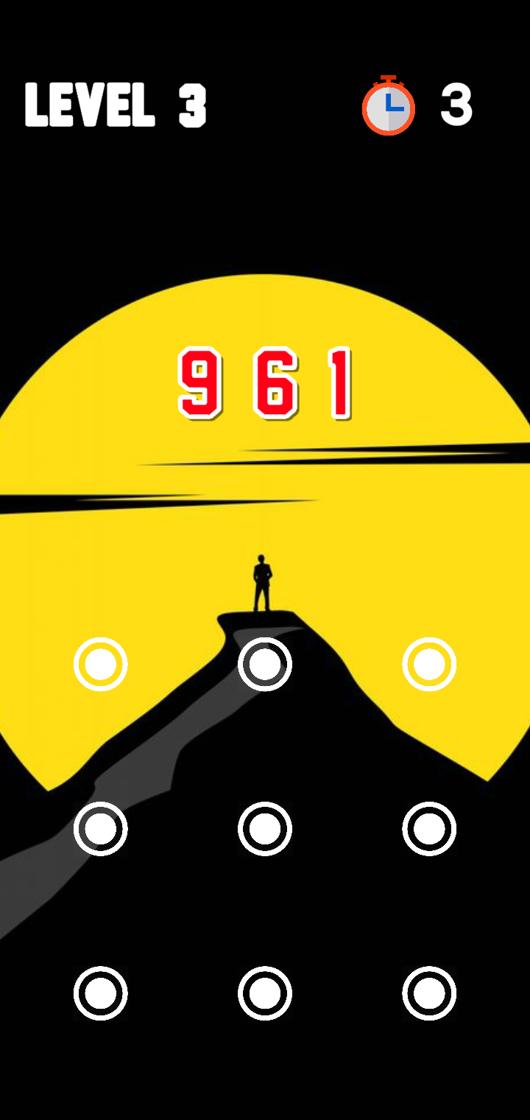

**Fig 21: Normal Screen**

### 4.9.5 Memorise Chapter

In memorise chapter we memorize the random number. The random number is set out over the screen in few seconds, after the number disappears. One should remember the number and drag the dots within a given time limit. This chapter notices how much memory power you have. It enhances the grasping capability of your brain. If u attempt all the three questions you won a gold medal. Likewise, two for silver and one for bronze medal.



**Fig 22: Memorise Screen**

### 4.9.6 Reverse Chapter

In Reverse chapter the random number is generated. The player is to look at the displayed number and connect the dots in reverse ordered, drag over the buttons on the screen within a given time limit. In this chapter it embraces 20 levels. Each level had three different question size setters. If you attempt three queries you won gold medal. Two for silver and one for bronze medal.

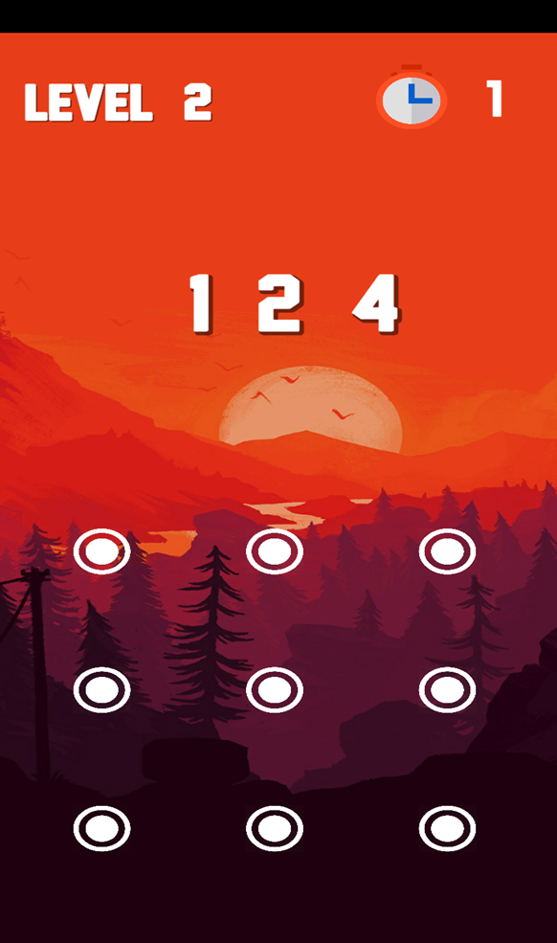

**Fig 23: Reverse Screen**

### 4.9.7 Alfabeto Chapter

In Alfabeto chapter the random set of alphabets are generated. The player wants to consider those 9 dots as numbers and alphabets, drag over the buttons on the screen with in a given time limit. In this chapter it embraces 20 levels. Each level had three different question size setters. If you attempt three queries you won gold medal.



**Fig 24: Alfabeto Screen**

### 4.9.8 Advanced Chapter

Advanced chapter is a 4x4 matrix, here the 16 dots is displayed on the screen in a chronological order. It is the difficult chapter and last one in classic mode. The length of the query is same as 3x3 matrix. The player should drag the dots according to the given random number in a given time. In advanced mode the time limit is same as previous modes one should practice those three chapters then get an experience and attempt this chapter as well. Like other three chapters if you attempt all the three you won gold medal, two for silver and one for bronze.



**Fig 25: Advanced Screen**

### 4.9.9 Result Screens

Each level is filled with 3 questions. If you correctly connect all 3 questions correctly then you will get Gold medal. If you connect only 2 Questions then you will get Silver. If you connect only 1 question then you get bronze medal. These medals are used to unlock the remaining chapters.

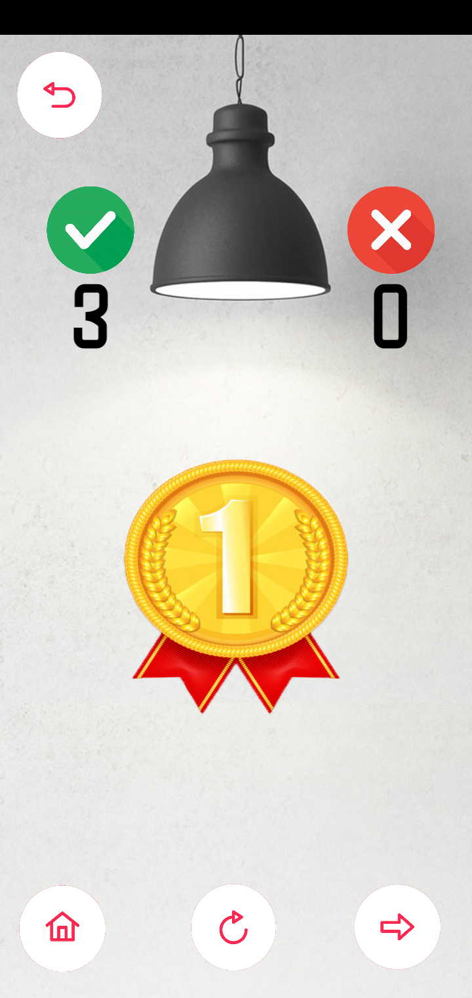

**Fig 26: Gold Medal Screen**

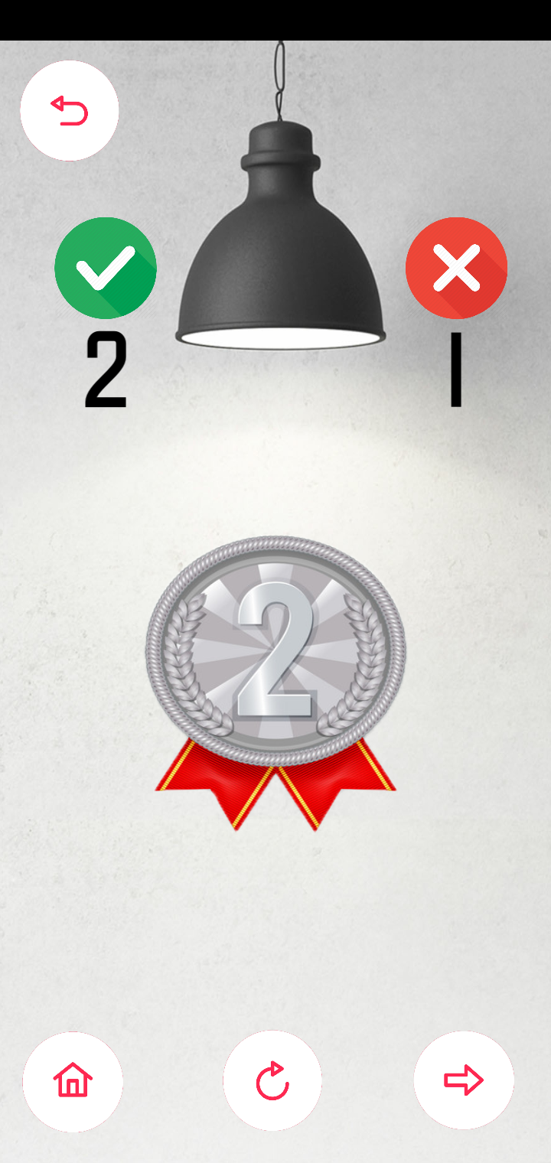

**Fig 27: Silver Medal Screen**

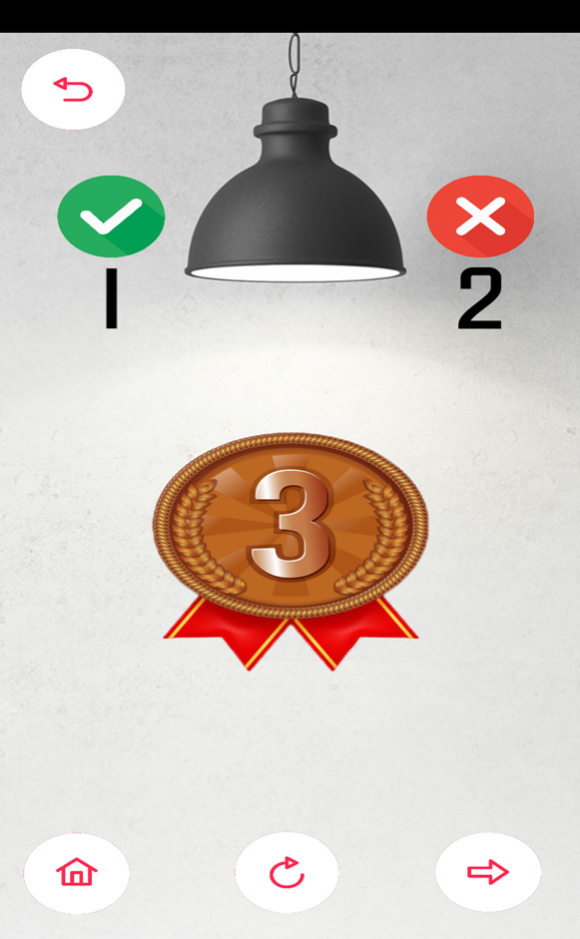

**Fig 28: Bronze Medal Screen**

### 4.9.10 Arcade

This is a screenshot of an Arcade mode. In an Arcade mode there are three types of games are there number one is Easy and next is Medium and the final one is Hard. In an Easy level the number pattern will give in easy, in a medium level some difficulty will increase it means the pattern size increases and in Hard the difficulty increases more comparing to both levels. The Arcade mode has time limit here we were allotted sixty seconds of time within the time the player can match as many as possible matches.

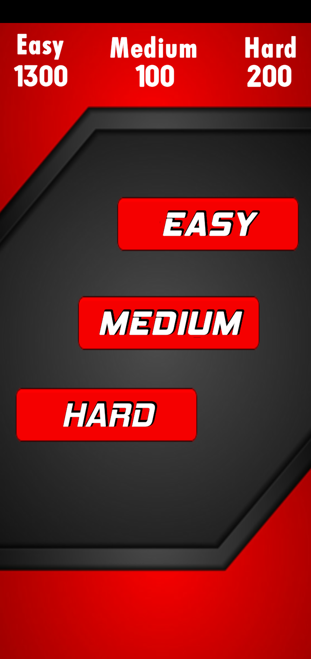

**Fig 29: Arcade mode**

**Easy level**

In easy level the pattern will be given with lesser Number (3-5 digits) so the player can play easily matches as many as possible within the required time and the given time for these levels is sixty seconds.



**Fig 30: Easy level screen**

**Medium level**

In a Medium level the Number will be increased while comparing to easy level because to increase the difficulty in Medium level. The size of number will be (5-7) digits.

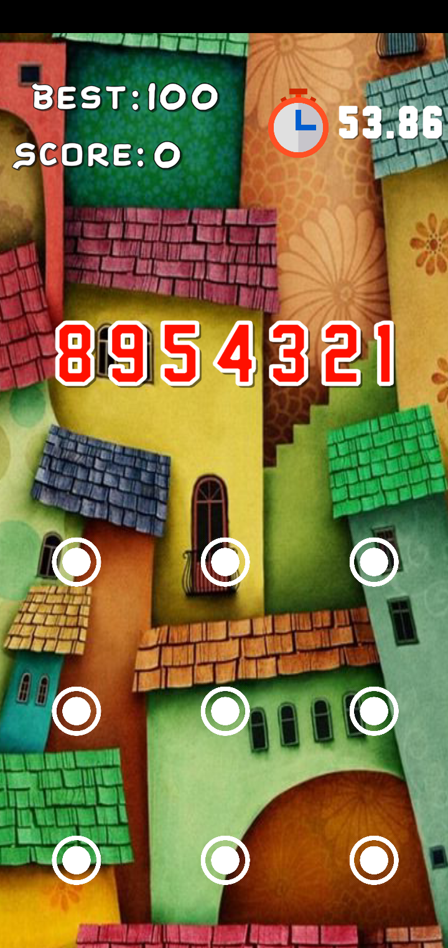

**Fig 31: Medium level screen**

**Hard level**

In Hard level the difficulty will increase more while compare to Easy and Medium levels. The Hard level will have number size (7-9) the player can match as many as possible within the time limit.

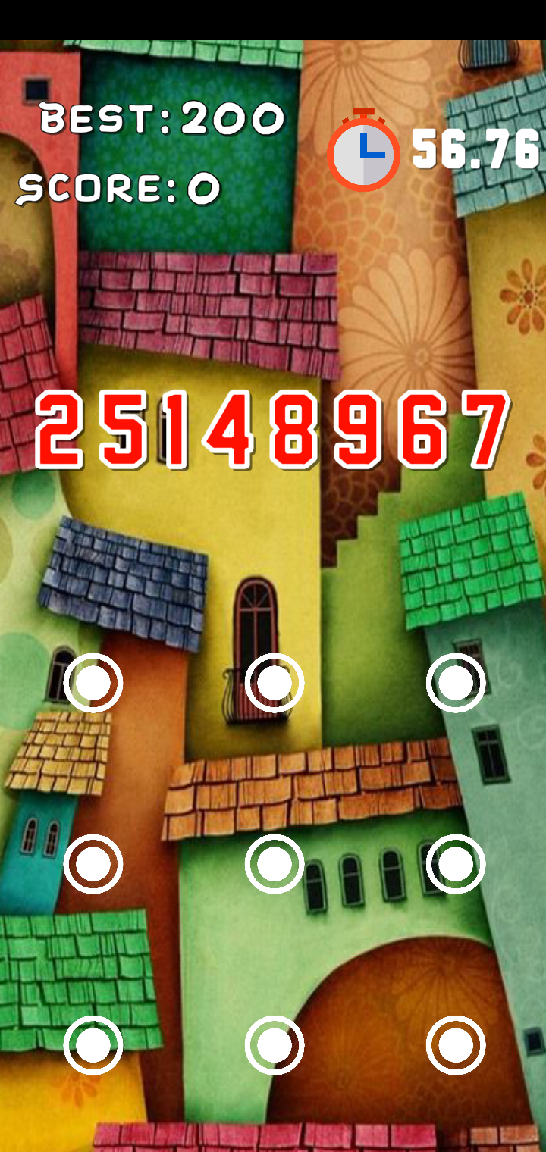

**Fig 32: Hard level screen**

**Score board**

This is the way the score board will appear in the Arcade mode the players best score and the players present score. And there are three buttons provided one is for to go home page and another one is for back to game button and one for retry

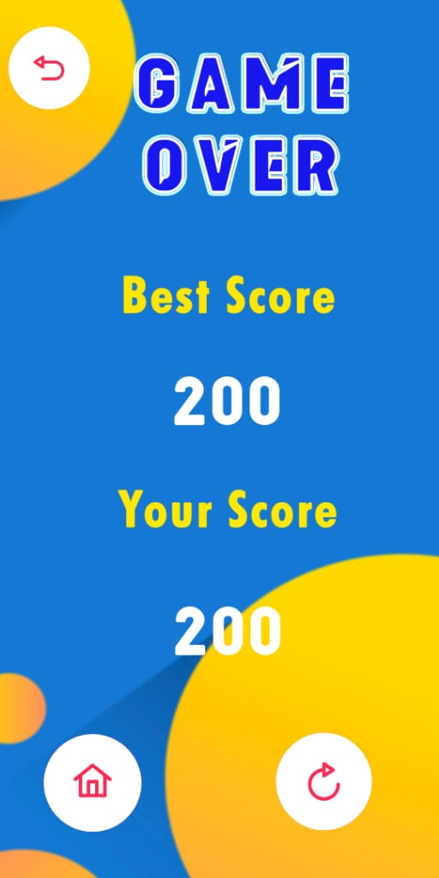.

**Fig 33: Score board screen**

### 4.9.11 Guide

In Guide player can find all information about the game and how many medals required to unlock consecutive chapters ad sample demo screens.

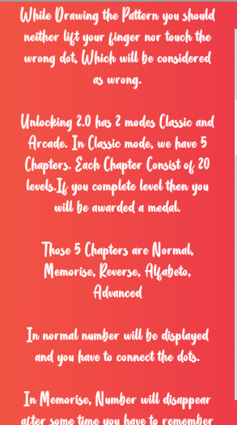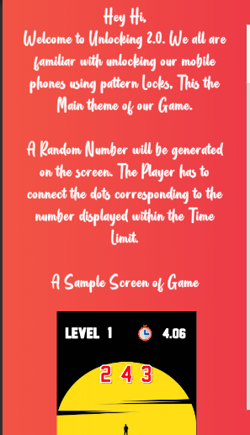

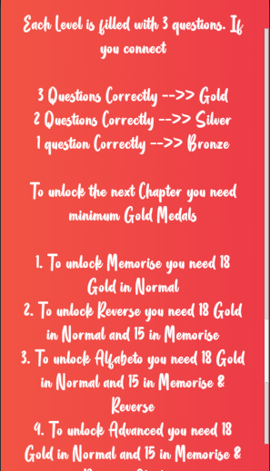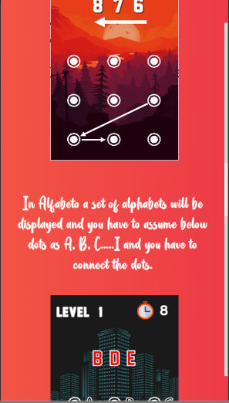

**Fig 34: Guide Screens**

These are all the different possible output game screen of this game.

# 

# CHAPTER 5: GAME TESTING

## 5.1 Introduction and Overview

**Game testing**, a subset of Game Development, is a software testing process for quality control of video games. The primary function of game testing is the discovery and documentation of software Defects (also known as bugs). Interactive entertainment software testing is a highly technical field requiring computing expertise, analytic competence, critical evaluation skills, and endurance. In recent years the field of game testing has come under fire for being excessively strenuous and unrewarding, both financially and emotionally.

In the early days of computer and video games, the developer oversaw all the testing. As games become more complex, a larger pool of QA resources, called "Quality Assessment" or "Quality Assurance" is necessary. Most publishers employ a large QA staff for testing various games from different developers. Now most game developers rely on their highly technical and game savvy testers to find glitches and 'bugs' in either the programming code or graphic layers. Game testers usually have a background playing a variety of different games on a multitude of platforms. They must be able to notate and reference any problems they find in detailed reports, meet deadlines with assignments and have the skill level to complete the game titles on their most difficult settings.

## 5.2 Methods used for Game Testing

There is no standard method for game testing, and most methodologies are developed by individual game developers. Methodologies are continuously refined and may differ for different types of games. Many methods, such as unit testing, are borrowed directly from general software testing techniques. Outlined below are the most important methodologies, specified for games.

* **Functionality testing** is most commonly associated with the phrase "game testing", as it entails playing the game in some form. Functionality testing does not require extensive technical knowledge. Functionality testers look for general problems within the game itself or its user interface, such as stability issues, game mechanic issues, and game asset integrity.
* **Compliance testing** is the reason for the existence of game testing labs. First-party licensors for console platforms have strict technical requirements titles licensed for their platforms some of these requirements are highly technical and fall outside the scope of game testing. Other parts, most notably the formatting of standard error messages, handling of memory card data, and handling of legally trademarked and copyrighted material, are the responsibility of the game testers. The requirements are proprietary documents released to developers and publishers under confidentiality agreements.
* **Compatibility testing** is normally required for pc titles, nearing the end of development as much of the compatibility depends on the final build of the game. Often two rounds of compatibility tests are done - early in beta to allow time for issue resolution, and late in beta or during release candidate. Compatibility testing team test major functionality of the game on various configurations of hardware. Usually a list of commercially important hardware is supplied by the publisher.
* **Localization testing** act as in-game text editors. Although general text issues are a part of functionality testing, QA departments may employ dedicated localization testers. Early Japanese game translations were rife with errors, and in recent years localization testers are employed to make technical corrections and review translation work of game scripts - catalogued collections of all the in-game text. Testers’ native to the region where a game is marketed may be employed to ensure the accuracy and quality of a game's localization.
* **Soak testing** in the context of video games, involves leaving the game running for prolonged periods time in various modes of operation, such as idling, paused, or at the title screen. This testing requires no user interaction beyond initial setup and is usually managed by lead testers.
* **Beta testing** is done during beta stage of development. Often this refers to the first publicly available version of a game. Public betas are effective because thousands of fans may find bugs that the developer's testers did not.
* **Multiplayer testing** may involve separate multiplayer QA team if the game has significant multiplayer portions. This testing is more common with PC games. The testers ensure that all connectivity methods (modem, LAN, Internet) are working. This allows single player and multiplayer testing to occur in parallel.
* **Mobile game** testing is mainly done manually or as automated during the development. Mobile game testing typically includes all above testing types. Popular mobile game platforms are android and iOS. Mobile game test automation with image recognition features can be found in Test droid.

## 5.3 What is Test Case?

A Test Case is a set of actions executed to verify a particular feature of our software application. Now, consider an example for the Test Scenario Check Login Functionality, there many possible cases like

**Test Case 1:** Check results on entering valid User Id & Password

**Test Case 2:** Check results on entering Invalid User ID & Password

**Test Case 3:** Check response when User ID is Empty & Login Button is pressed, and many more.

This is nothing but Test Case. Test scenarios are rather vague and cover a wide range of possibilities. Testing is all about being very specific. Hence, we need Test Cases.

## 5.4 Testing and Validation

Different methods, such as unit testing, are borrowed directly from general software testing techniques. There is no standard method for game testing, and most methodologies are developed by individual game developers. Methodologies are continuously refined and may differ for different types of games. In this game, no software is used for testing and is done manually. The basic focus is on functionality, compatibility and soaks testing. These testing were finalized during ‘Beta’ phase of the game production.

Software validation checks that the software product satisfies or fits the intended use (high-level checking), i.e., the software meets the user requirements, not as specification artifacts or as needs of those who will operate the software only; but, as the needs of all the stakeholders (such as users, operators, administrators, managers, investors, etc.). There are two ways to perform software validation: internal and external. During internal software validation, it is assumed that the goals of the stakeholders were correctly understood and that they were expressed in the requirement artifacts precise and comprehensively. If the software meets the requirement specification, it has been internally validated. External validation happens when it is performed by asking the stakeholders if the software meets their needs.

Following shows the testing reports on this game:

|  |  |  |  |  |  |  |
| --- | --- | --- | --- | --- | --- | --- |
| S. No | Test Description | Execution Steps | Expected Result | Actual Result | | Pass/ Fail |
|  | Scene Manager Screen Application | 1.Expand the applications  2.Show game logo and game menus | When a user clicks the game icon in his/her mobile device, it should display him a game logo followed by the game menus.  The menus like new game, options, help and exit should be displayed in this case. | Game logo is displayed.  Menus are displayed. | | Pass |
|  | Loading an Application | Click on icon. | Select an Application icon.  Game must open to a menu scene without delay. | Game is loaded within 5 seconds.  It is a minimum loading time for any android application. | | Pass |
|  | Selecting Classic mode in the Available modes | Select Classic option from menus.  Click on Classic mode. | Once a player chooses a mode and clicks a mode, Game must open with Chapters scene without any delay. | Chapter scene is displayed with 4 Chapters, where only Normal Chapter is Unlocked. | | Pass |
|  | Starting the new game | Select Normal option from chapters.  Click on level 1. | Once a player chooses a Normal chapter and clicks a level, the game must start. | New game was started with only one level unlocked that is level 1. | | Pass |
|  | Unlocking the new level. | Open application.  1.Start the level  2.Complete the recent level. | When a player completes the recent level with a minimum medal, then the next level should be unlocked. | Level 2 is played  and completed. The new level 3 is unlocked. | | Pass |
|  | Increase in score | Play the game  1.Complete all the three games  2.Get gold medal | Player needs to match the pattern with number displayed on the scene.  If player complete all the three games given in a level then player can be able to get gold medal, if completed only games able to get silver medal, if completes only single game bronze medal is given. | Keep on practicing and playing the game helps the player to reach the gold medal after completing all the three game within the time limit. | | Pass |
|  | Saving the medals | Play each level  Get medal  Check medal | On completion of each level certain medals are obtained by the player. These medals are stored based on each level. And medals must be displayed in each level icon. | Level 1 was cleared; gold medal was obtained. This medal was displayed on the bottom of level 1 icon | | Pass |
|  | Updating high medal | Play the level again to beat the previous medal. | If same level is played again, and obtain the high medal, the high medal must be updated. | Level 1 was played again the new medal was gold. The new high medal was updated to gold for level 1. | | Pass |
|  | Level completion display | Complete the level | Once the level is completed, level completion message should be displayed. | Player completed the level 1 and level completion message with small greeting was displayed. | | Pass |
|  | Back button | Going to Level scene | Clicking on Back button should take the player to Level scene | Player will be taken to Level scene after immediately clicking the Back button | Pass | |
|  | Next  button | Going to Next Level | Clicking on Next button should take the player to next Level only if the player gets minimum of bronze medal in the current level | Player will be taken to next Level after immediately clicking the Next button after getting minimum of bronze medal | Pass | |
|  | Home  button | Going to Main Menu | Clicking on Home button should take the player to Main Menu scene | Player will be taken to Main Menu scene after immediately clicking the Home button | Pass | |
|  | Unlocking next chapters | Get Minimum required medals in the current Chapter | Player need to get some minimum required medals to unlock the next consecutive Chapters | User after reaching the Minimum required medals in the current Chapter can able to Unlock the next consecutive Chapters | Pass | |
|  | Unlock Memorise  Chapter | Complete the Normal Chapter | To Unlock the Memorise Chapter player, need to get Minimum of 18 gold medals in Normal Chapter | User will be Unlocked the Memorise Chapter after reaching 18 gold medals in the Normal Chapter | Pass | |
|  | Unlock  Reverse  Chapter | Complete the Memorise Chapter | To Unlock the Reverse Chapter player, need to get Minimum of 15 gold medals in Memorise Chapter | User will be Unlocked the Reverse Chapter after reaching 15 gold medals in the Memorise Chapter | Pass | |
|  | Unlock Alfabeto Chapter | Complete the Reverse Chapter | To Unlock the Alfabeto Chapter player, need to get Minimum of 15 gold medals in Memorise Chapter | User will be Unlocked the Alfabeto Chapter after reaching 15 gold medals in the Reverse Chapter | Pass | |
|  | Unlock  Advanced  Chapter | Complete the Alfabeto Chapter | To Unlock the Advanced Chapter player, need to get Minimum of 15 gold medals in Alfabeto Chapter | User will be Unlocked the Advanced Chapter after reaching 15 gold medals in the Alfabeto Chapter | Pass | |
|  | Random number generated | Number generated should be unique and vary from game to game | Each time player open the game Number generated should be different and unique and should vary from game to game | User will feel the difference of the Number generated and each time user opens the same game different number will be generated using the Random function | Pass | |
|  | Random Number Generated | Number generated should be unique and vary from game to game | Each time player open the game Number generated should be different and unique and should vary from game to game | But Sometimes Same number may be generated (1% probability) | Fail | |
|  | Matching the Pattern | Match the pattern with Number generated | Player need to match the Number with the Number generated to complete the game if else player couldn’t match the pattern moves to another game immediately. | User match the Number with the Number generated and complete the game if else player couldn’t match the pattern moves to another game immediately. | Pass | |
|  | Setting Time | Each game should be completed in the given time | Player needs to match the pattern within the time given | User will be matching the pattern within time to get medals. Time will be vary from level to level based on the difficulty | Pass | |
|  | Increasing the Difficulty in the Levels | Level to Level difficulty should be Increased | Player need to feel the difficulty from Level to Level | User will be feeling difficulty from Level to Level based on the increase in the size of the digit of the number to be matched and decrease in the time | Pass | |
|  | Selecting Arcade mode in the Available modes | Select Arcade option from menus.  Click on Arcade mode. | Once a player chooses a mode and clicks a mode, Game must open with Modes scene without any delay. | Chapter scene is displayed with 3 modes.  1.Easy  2.Medium  3.Hard | Pass | |
|  | Play Easy Mode | Select Easy mode from Arcade mode | Time will be 60sec in Easy mode with a smaller number  (3-5) | User will be given with the 60sec of time and less digits of number will be displayed to decrease the difficulty of the game. | Pass | |
|  | Play Medium Mode | Select Medium mode from Arcade mode | Time will be 60sec in Medium mode with a Average number (5-7) | User will be given with the 60sec of time and average digits of number will be displayed to set the medium difficulty of the game. | Pass | |
|  | Play Hard Mode | Select Hard mode from Arcade mode | Time will be 60sec in Hard mode with number (7-9) | User will be given with the 60sec of time and large digits of number will be displayed to increase the difficulty of the game. | Pass | |
|  | Score Updating in Arcade Mode | Each time Score should be Updated | Each time Player plays the Arcade game high score should be updated | User after playing the Arcade game every time High score will be Updated | Pass | |
|  | Storing the High Score  In Arcade Mode | Update the High Score | Check for the previous score and compare the both scores and update the highest score as the High Score | User previous score will be checked and compared the both scores and update the highest score as the High Score | Pass | |
|  | Pattern Matching | Match pattern with the Number generated | Player should be matching the number with the pattern and system should detect whether the patter matches with the number or not | user will be matching the number with the pattern and system should detect whether the patter matches with the number or not | Pass | |
|  | Ads | Ads included in the game for Monetization | Ads should be inserted in the game through the Google AdSense for Monetization | Ads are inserted and implemented in the game through the Google AdSense for Monetization | Pass | |
|  | Ads | Ads included in the game for Monetization | Ads should be inserted in the game through the Google AdSense for Monetization | Sometimes ads fail to fetch and display | Fail | |
|  | Setting background music | Go to menu  Click ‘Options’  Turn ON/OFF background music. | A player can  either turn ‘ON’ or turn ‘OFF’ the background music. If turned ‘OFF’, the music should not be played on the game-play and vice-versa. | Player turned off the background music on the main screen.  No background music was played on the game play. | Pass | |
|  | Navigate to guide option | Go to menus  Click the ‘guide menu’ | If user seeks any help on the game play, he can gather the information from guide menu. | User clicked the ‘Guide’ menu; the game play information was displayed. | Pass | |
|  | Checking  Rate Us  button | In Main Menu  Click on Rate Us | Player should be Redirected to Play store “UnlocKing” Page for giving the Reviews and Ratings | User Redirected to Play store “UnlocKing” Page for giving the Reviews and Ratings | Pass | |
|  | Exit the game | Go to main menu  Click on ‘Exit’ button | On clicking the ‘Exit’ button; the game must quit. And the control must return to the Android home screen. | Player clicked the ‘Exit’ button to quit the game and finally return to his home screen. | Pass | |

**Table 5.4.1: Testing and Validation**

# CHAPTER 6: CONCLUSION & FUTURE ENHANCEMENT

## 6.1 Conclusion

According to Newzoo.com gaming is at the heart of the entertainment business. The way consumers engage with and through games is constantly changing. Not only does this result in more overall engagement, but it also leads to entirely new segments of game enthusiasts. There are now more than **2.5 billion gamers across the world**. Combined, they will **spend $152.1 billion on games in 2019**, representing an increase of +9.6% year on year. **Mobile gaming (smartphone and tablet), meanwhile, remains the largest segment in 2019, growing +10.2% year on year to $68.5 billion** 45% of the global games market. Of this, $54.9 billion will come from smartphone games.

In 2020, the **global games market will generate revenues of more than $160 billion**, increasing +7.3% year on year. Newzoo.com present our forecasts for the global games market toward 2022. **Consumer spend on games will grow to $196.0 billion by 2022**, a CAGR (Compound Annual Growth Rate) of +9.0% between 2018 and 2022.

Mobile gaming will generate revenues of $95.4 billion in 2022 and account for almost half of the entire games market. This will be driven predominantly by smartphones, with revenues of $79.7 billion by 2022. Although mobile is indeed still the world’s fastest-growing games market segment, growth is slowing in mature markets such as North America, Western Europe, and Japan. Emerging markets, including Southeast Asia, India, and Middle East & North Africa, will contribute most to the segment’s growth. However, a range of other factors are also contributors, including more cross-platform titles, more smartphone users, and improvements to both mobile hardware and mobile Internet infrastructure, including the rollout of 5G networks.

As of that period, Android users were able to choose between 2.87 million apps in its store. The number of smartphone users worldwide today surpasses three billion and is forecast to further grow by several hundred million in the next few years. China, India, and the United States are the countries with the highest number of smartphone users, with each country easily surpassing the 100 million user mark. So, there is huge market for mobile games. So, we have targeted the android users to implement our game. Any device with minimum of android version 4.1 (jelly bean) and more can easily run this game. It’s just a Puzzle game clearing the levels. It’s a free game available in the play store. Any age group, who can differentiate the things and its components, can easily play this game. This game basically increases the response time and concentration levels of the user as the decision should be quick and appropriate.

## 6.2 Future Enhancement

Present we have uploaded our app in play store getting good reviews and downloads along with some income through ads.

Following are the future enhancement of this game:

* New levels and chapters will be added
* Improved user interface.
* Flexible for online and offline environment.
* More confusing and unique levels will be introduced
* Premium version with no ads.
* Launch in AppStore

# CHAPTER 7: REFERENCES

1. Installing Unity: <https://www.youtube.com/watch?v=_QWSNB1_SxU>
2. Installing Visual Studio: <https://www.youtube.com/watch?v=2PVPz8Pnnrw>
3. Basic Unity Tutorials: <https://www.youtube.com/watch?v=Ep0rlBQRcVc>
4. Unity User Manual: <https://docs.unity3d.com/Manual/index.html>
5. Basic Krita usage: <https://www.youtube.com/watch?v=kUXNEK8awiY>
6. Krita User Manual: <https://docs.krita.org/en/>
7. Basic Illustrator usage: <https://www.youtube.com/watch?v=Kgmu8RwLi28>
8. The complete beginners guide to Adobe Illustrator:
9. <https://www.pgsd.org/cms/lib07/PA01916597/Centricity/Domain/202/illustrator_for_beginners_tastytuts.pdf>
10. Basic Photoshop usage: <https://www.youtube.com/watch?v=pFyOznL9UvA>
11. Photoshop User Manual: <https://helpx.adobe.com/in/photoshop/user-guide.html>